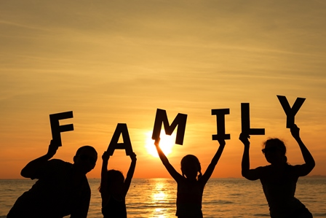

**Thank you for our FAMILIES and all who care for us. We pray for people who are separated from their families.**