How did Rome begin?
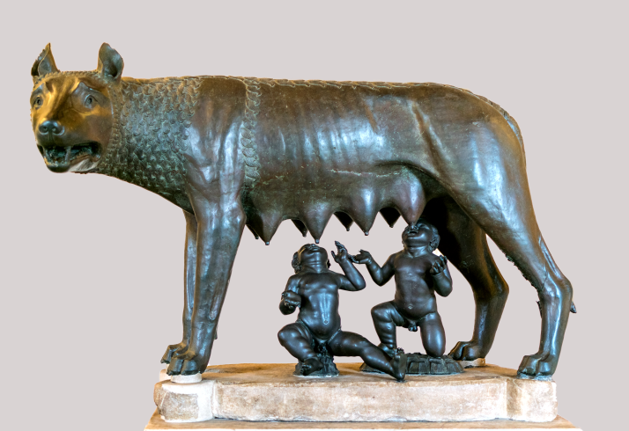 | According to legend, Rome was founded by twin brothers, Romulus and Remus, who were the sons of the God Mars.  As babies, the boys were left to drown in the River Tiber by order of their evil uncle, the King. Their cradle was carried downstream onto the river bank where they were looked after by a she-
wolf until they were discovered by a shepherd and his wife. They took the boys home and brought them up as their own sons.
When the boys were older they took revenge on their uncle. They killed him and decided to start a new city. The twins argued and fought about where the new city should be and Remus was killed. Romulus then made himself King of the new city and called it Rome.

Task: heads and tails (a)

Copy the sentence starters and match to the correct endings.

Starters  Romulus and Remus were …  The order to drown them was given by their …  Their cradle was thrown into …  The twins were found …  While building the city …  Rome was … |  | Endings  … named after Romulus, the new King.  … the twins argued and Remus was killed.  … evil uncle who was King.  … by a she-wolf.  … twin brothers.  … the River Tiber.

Task: heads and tails (b)

Cut out and the sentence starters and endings neatly. Match up and stick the correct sentence starter and ending.

Starters | Endings
Romulus and Remus were | named after Romulus, the new King.
The order to drown them was given by their | the twins argued and Remus was killed.
Their cradle was thrown into | evil uncle who was King.
The twins were found | by a she-wolf.
While building the city | twin brothers.
Rome was | the River Tiber.
© Di Rabax63 - Opera propria, CC BY-SA 4.0, https://commons.wikimedia.org/w/index.php?curid=69187000

