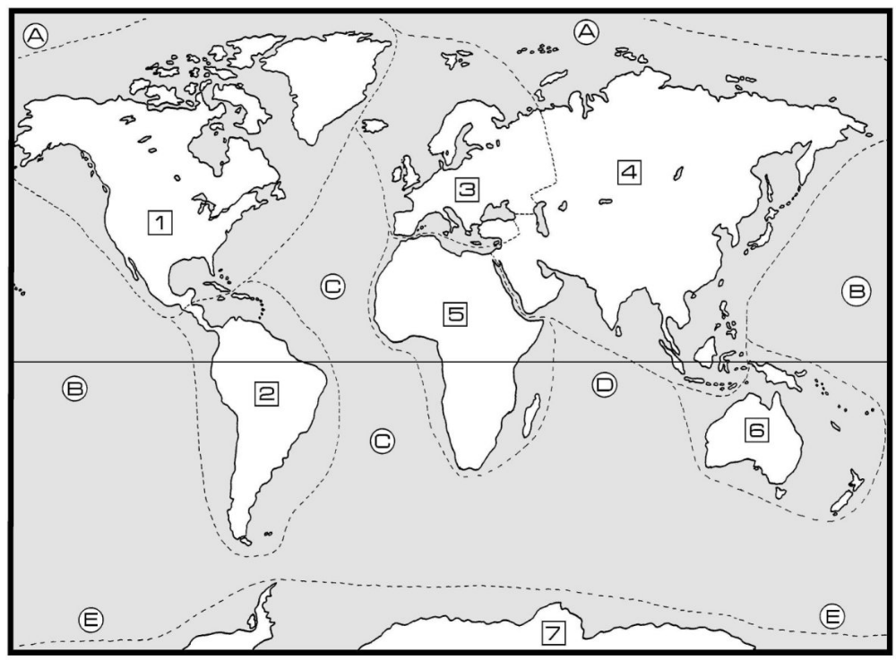
Geography – The World
Continents:
1______________
2______________
3______________
4______________
5______________
6______________
7______________

Oceans:
A______________
B______________
C______________
D______________
E______________

