Parent Survey Response
Thank you for such a good response to our Parent Survey (May 2020) – 46% of you responded (33% is regarded as a typical response) We have been so encouraged by your positive comments, particularly recognising our Langley Fitzurse strengths – being a warm, loving school with a family feel, where we live out our values.

- Agreed Langley Fitzurse is a good church school
- Agreed we have excellent links with St Peter’s
Church and the Draycot team
- Agreed that everyone is valued
- Recognised positive links with our community
- Are happy and feel welcome to attend Collective Worship and school services
- Are happy with the RE provided

However, 6.9% would like more information about the RE curriculum
3.4% did not agree that our school contributed to the spiritual life of pupils, parents and staff
ACTION

YOU ASKED - Could school services be at other times of day for working parents?
LF reply – We try to offer a variety of times and days throughout the year so that as many parents as possible can attend (morning and afternoon). We also try and give plenty of notice to make it easier for you to plan.

YOU ASKED – Please continue with the church/school partnership and close involvement.
LF reply – Both Langley Fitzurse Primary School and St Peter’s Church are committed to our partnership, and this will be protected as part of any federation.

YOU ASKED – What has happened to Langley Fitz’s contact with Union Chapel?
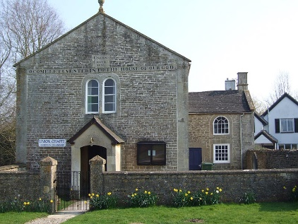
LF reply – Our school has had a long relationship with our next door neighbour, Union Chapel. As pastors come and go that relationship changes, depending on their time pressures. Pastor Rod and Diane Westrop both worked but helped out with our Experiences. Pastor Thanos is settling in and we are keen to find new ways of working together.
YOU ASKED – How can we develop links with older people in our community?
LF reply – Over the years we have invited villagers to coffee mornings and shared our joyful singing. As part of our 11 by 11 project, we were exploring how Y5 and 6 pupils might join in the Thursday Chapel Rendezvous coffee morning. COVID 19 has put this on hold for the moment. If you have other ideas, please do share them with our staff team.

YOU ASKED – Will RE offer different points of views and interpretations of the Bible, and explore some of the challenging messages? For example, in relation to Creation.
LF reply – The Understanding Christianity resources we now use in RE explore the main concepts in Christianity, including Creation. Pupils look at the text of the Bible, how people interpret it, and how they make connections in their own lives. There are starting questions such as ‘Who made the world?’, ‘What do Christians learn from the Creation story?’ and ‘Creation and science: conflicting or complementary?’ We look at the Christian belief of God as Creator, our responsibilities, how we care for the world and thankfulness for our amazing planet.

You don’t have to wait for a survey to tell us what you think or ask questions! Please speak to your class teacher, the headteacher Mrs Winterburn or one of the foundation governors, Mrs Harriet Wilkinson or Mr Huw Solly.

July 2020

