What is Child Protection?

Child protection is the process of protecting children and young people who have been identified as suffering, or likely to suffer harm as a result of abuse.
There are four types of abuse: Physical
Sexual
Emotional
Neglect

Safeguarding is the action that people take to keep all children safe, for example:
- Protect children from harm
- Ensure that they are safe and well looked after
- Take action so that all children are able to grow up in a safe environment.

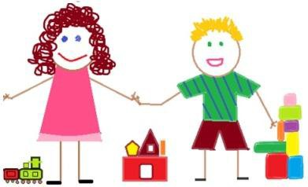

ALL CHILDREN HAVE A RIGHT TO BE PROTECTED FROM HARM
What does your school have to do?

Your school must have a senior member of staff who is responsible for child protection. This person has the title of Designated Safeguarding Lead (DSL) and this is Kay Vousden. The Deputy Designated Safeguarding Leads are Ros Hutchins and James Osler.

Your school will have a Child Protection Policy. This document will set out the process for dealing with child protection concerns. If you would like to read this policy you may find it on your school’s website. Alternatively the school can provide you with a copy; please ask at your school reception.

This policy will also set out the process for reporting allegations about members of staff, including volunteers.

All adults in school, including volunteers, must have regular training to ensure that they are aware of the signs of abuse and know what to do about their concerns.
They have a duty to report these to the Designated Safeguarding Lead.

Your school has a legal duty to talk to other agencies such as Children’s Social Care and the Police if they think a child may be at risk of harm.

What do you need to know?
If anyone in school is worried about the welfare of your child this will be discussed with you unless they think that this conversation could put your child at a greater risk of harm.

The school must also share all relevant information with Children’s Social Care if they are concerned about your child.

The social worker may consult with other agencies before deciding what should happen next. They will also speak to you about the concern and keep you informed about what is happening.

If there is an allegation about an adult who works at the school, the school will hold discussions with the Police and Children’s Social Care. If your child is involved, you will be kept informed of any discussions and decisions as appropriate.

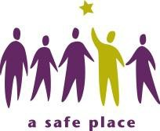

FAMILIES HAVE A RIGHT TO EXPECT SCHOOLS TO PROVIDE A SAFE AND SECURE ENVIRONMENT FOR CHILDREN

You will find additional information at:
- The Wiltshire Safeguarding Children Board: www.wiltshirelscb.org.uk

- The Department for Education website:

www.gov.uk/government/publications/keeping-children-safe-in-education--2

Keeping children safe in Education 2015 DFE-00129-2015

THE WELFARE OF YOUR CHILD IS OF PARAMOUNT IMPORTANCE

Your child will find more information at: www.childline/org.uk
Free 24-hour telephone helpline:
0800 1111

This leaflet was jointly produced by Wiltshire Council and the Wiltshire Safeguarding Children Board (WSCB).

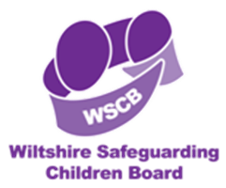

SH - June 2015
LA circulation no P035/15
Last updated by Langley Fitzurse CE Primary School January 2018

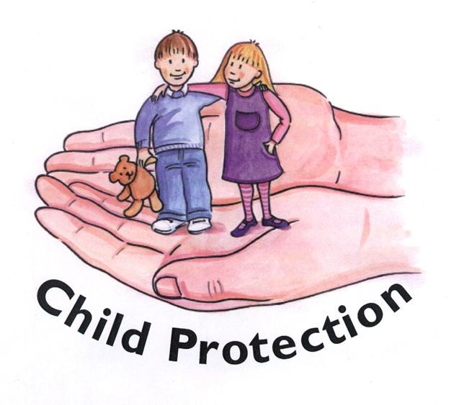
Langley Fitzurse
CE Primary School

