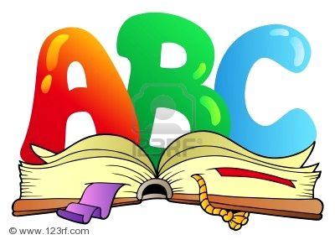
Phonics and Spelling at Langley Fitzurse Primary School
At Langley Fitzurse we follow the ‘Letters and Sounds’ phonic programme with ‘Jolly Phonics’ actions and pictures to support this. In the Foundation Stage, our phonic skills begin with speaking and listening. We practise listening for sounds (phonemes) at the beginning, in the middle, and at the ends of words. We also practise blending sounds together verbally to make words. We then begin learning single letter sounds. Pupils learn the sound, the action and the formation of each letter. As the children become more confident, we teach them how to put these single sounds together to read and write words. Throughout the EYFS, we constantly reinforce the importance of correct formation of these letters, practising in different ways, such as using glitter, sand and playdough. We also focus on learning High Frequency words, which the children learn by sight.
In Key Stage 1 the children continue to follow the ‘Letters and Sounds’ programme linked with the Primary National Curriculum spellings. These high frequency words are statutory words that are set out in the primary curriculum for each year group. Punctuation and grammar teaching also takes place in these sessions.
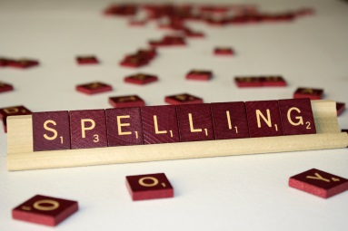
In KS2, the children are taught spelling, punctuation and grammar in daily class sessions, following the Primary National Curriculum statutory guidance. Phonics teaching will continue in intervention groups for those children who require it, and some children are given spellings to continue to learn at home.
The majority of the teaching of spelling will be done in school. Your child will have various spellings to work on, and the teacher will regularly assess how they are doing – this may be through asking them to spell words that have been taught during the week, spelling tests, or by writing down sentences that are dictated to them that use these spellings. Teachers select spellings from the statutory lists and differentiate appropriately across the class.

Reading at Langley Fitzurse Primary School
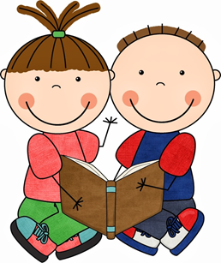
Children in EYFS take part in many book related activities which prepare them for independent reading. School reading books will be sent home. At first these may be wordless, so that children can practise their understanding of how books work, telling the story through the illustrations. They will move on to books with words when appropriate. All books will be accompanied by a Home Reading Record book for parents to sign and comment in.
Throughout KS1 and KS2 the children will continue to bring home reading books with a Home Reading Record Book. Comments are very useful in informing the teacher how the child has coped with the text. Regular reading at home is essential to good progress and we really appreciate parental support in hearing your child read as often as possible.
Children also have access to the Bug Club website. This is a resource of e-books that the children are encouraged to spend time using. Teachers select the level and nature of the book for each child, and regular comprehension questions are given throughout the books to ascertain their understanding. Teachers can also use this assessment information to plan their teaching and address misconceptions.
In school, children from Y1 upwards take part in weekly Guided Reading group with the class teacher or TA. Across all year groups, this is incorporated into a daily reading session, with a carousel of reading activities such as reading comprehensions, character description, dictionary work etc. We also aim to hear children in Reception, KS1 and KS2 read independently.
All children during their time at Langley Fitzurse will enjoy a range of texts. As well as ‘real’ books we use a number of reading schemes including Oxford Reading Tree, Project X, Collins Big Cat and Treetops In Fact.
