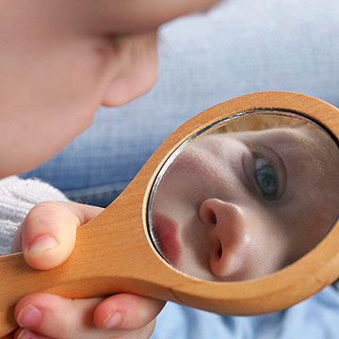

**As we REFLECT, help us to look back and be thankful, as well as learning from our mistakes.**