Langley Fitzurse is a Church of England Primary school. In 1856/7 the church founded this village school. Today, in partnership with the state, our church school aims to serve the local community by providing an education of the highest quality within the context of Christian belief and practice. It is one of the reasons we have a strong and active partnership with St Peter’s Church and the Draycot group of churches.

Why are we a Church School?
Our trust deeds commit us to preserving and developing the Christian character of this school in accordance with the principles of the Church of England, and in partnership with St Peter’s, our parish church, and the Diocese of Bristol. Christian distinctiveness requires the school to have a Christian vision which deliberately follows the teaching and example of Jesus, and its Christian character should be reflected in the way the school community lives and behaves. It is the responsibility of the whole governing board, headteacher and staff to make this a reality, supported and monitored through the Christian Distinctiveness Meeting, and through the pupils on the Worship Council.

How are we monitored as a Church School?
Every 3 – 5 years the school receives a SIAMS (Statutory Inspection of Anglican and Methodist Schools) inspection through Bristol Diocese. We are due an inspection at some point in 2021. Our school is currently graded as ‘Outstanding’.

At the end of 2016 the Church of England published a new vision for education in church schools called ‘Deeply Christian, Serving the Common Good’. This can be found at:

https://www.churchofengland.org/more/education-and-schools/education-publications
Below is a copy of the Executive Summary:
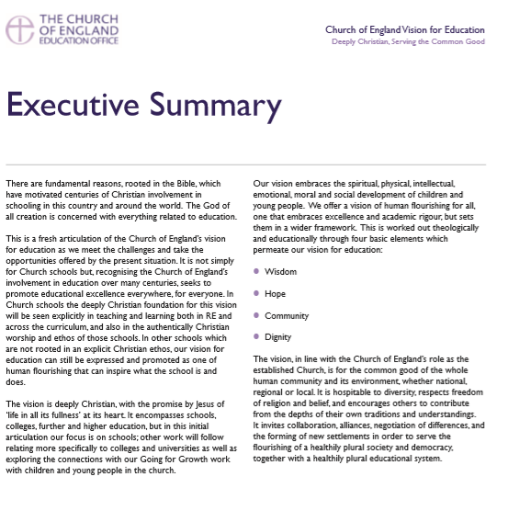
As a result, in 2018 the inspection framework was revised and a new schedule issued. There are new criteria and new grades. This is not a tick box exercise that can be completed just before the inspection is due – it is about celebrating the school’s Christian distinctiveness which is lived out day by day, year by year. It is clear that very few schools will achieve ‘Excellent’. In reality ‘Good’ is the new gold standard, but within that areas of excellence may be demonstrated. Therefore, it is important to inform staff, parents, our church partners and the wider community of this change and manage expectations.
A copy of the schedule can be found here:
https://www.churchofengland.org/more/education-and-schools/church-schools-and-academies/siams-school-inspections

What is being inspected?
The inspectors will grade the school on one question:

How effective is the school’s distinctive Christian vision, established and promoted by leadership at all levels, in enabling pupils and adults to flourish?

To gather evidence in order to answer this question the inspector will examine seven strands:
- Vision and Leadership
- Wisdom, Knowledge and Skills
- Character Development – Hope, Aspiration and Courageous Advocacy
- Community and Living Well Together
- Dignity and Respect
- The impact of collective worship
- The effectiveness of religious education
Evidence is summarised in a SEF (self-evaluation form), however the school website is a prime source of information and evidence for the inspectors.
Our School Vision
Who are we? Status and trust deed – context
Why are we here? Core purpose/vision in serving the local community
How then do we live? The role of Christian values
Motto
For many years the school motto has been ‘Amaze, Excite, Inspire’. Agreed that this is valued by the school community and remains relevant to the way Langley Fitzurse delivers high quality education to all. It also reflects the Church of England vision of ‘Life in all its Fullness’ John 10:10

Values
During the last school year, the governors, staff and pupils have worked together to identify the core values which are important to our school community. To live as ‘Family’ we need to develop and value Friendship, Respect, Truthfulness, Forgiveness, Perseverance and Service. These are human values, but because we are a Church of England school we try to explore and anchor them in the Christian faith, relating them to Bible teachings and the life of Jesus Christ.

Vision
This should influence everything we do as a school – set our priorities, inform our decision making, direct our resources, shape our policies and be evident in the school ethos and everyone’s behaviour.

The CDM have started work in developing a fresh vision for the school, seeking ideas from governors and parents. Still to consult with the staff team and pupils – but the draft is:

We are a friendly church school with a family feel who aim to amaze, excite and inspire confident, happy and resilient children to reach their full potential.

Aims – These are currently found on the school website – do they need refreshing?

To ensure that
- the spiritual, moral, social and cultural development of children prepares them for adult life and making a positive contribution to their community
- children feel happy, safe and secure
- children have basic moral values and are compassionate and respectful
- inquisitive minds are encouraged
- children value exceptional learning, that they persevere and build the skills to become independent, life-long learners
- children take satisfaction from trying new things and working hard
- children are given the lifelong gift of prayer
- equality is promoted, diversity is celebrated and prejudice is negated

Next Steps
RH, HW and KB have attended 2 days of excellent SIAMS training through Gloucester Diocese. Currently digesting and identifying a plan of action – CDM meets next 9th Jan 2020.

Governor Action
Please familiarise yourself with the 7 strands. We propose that each governor takes on a strand that fits with current responsibility. Start to gather evidence, ask questions and suggest actions that may be required to attain ‘Good’.

