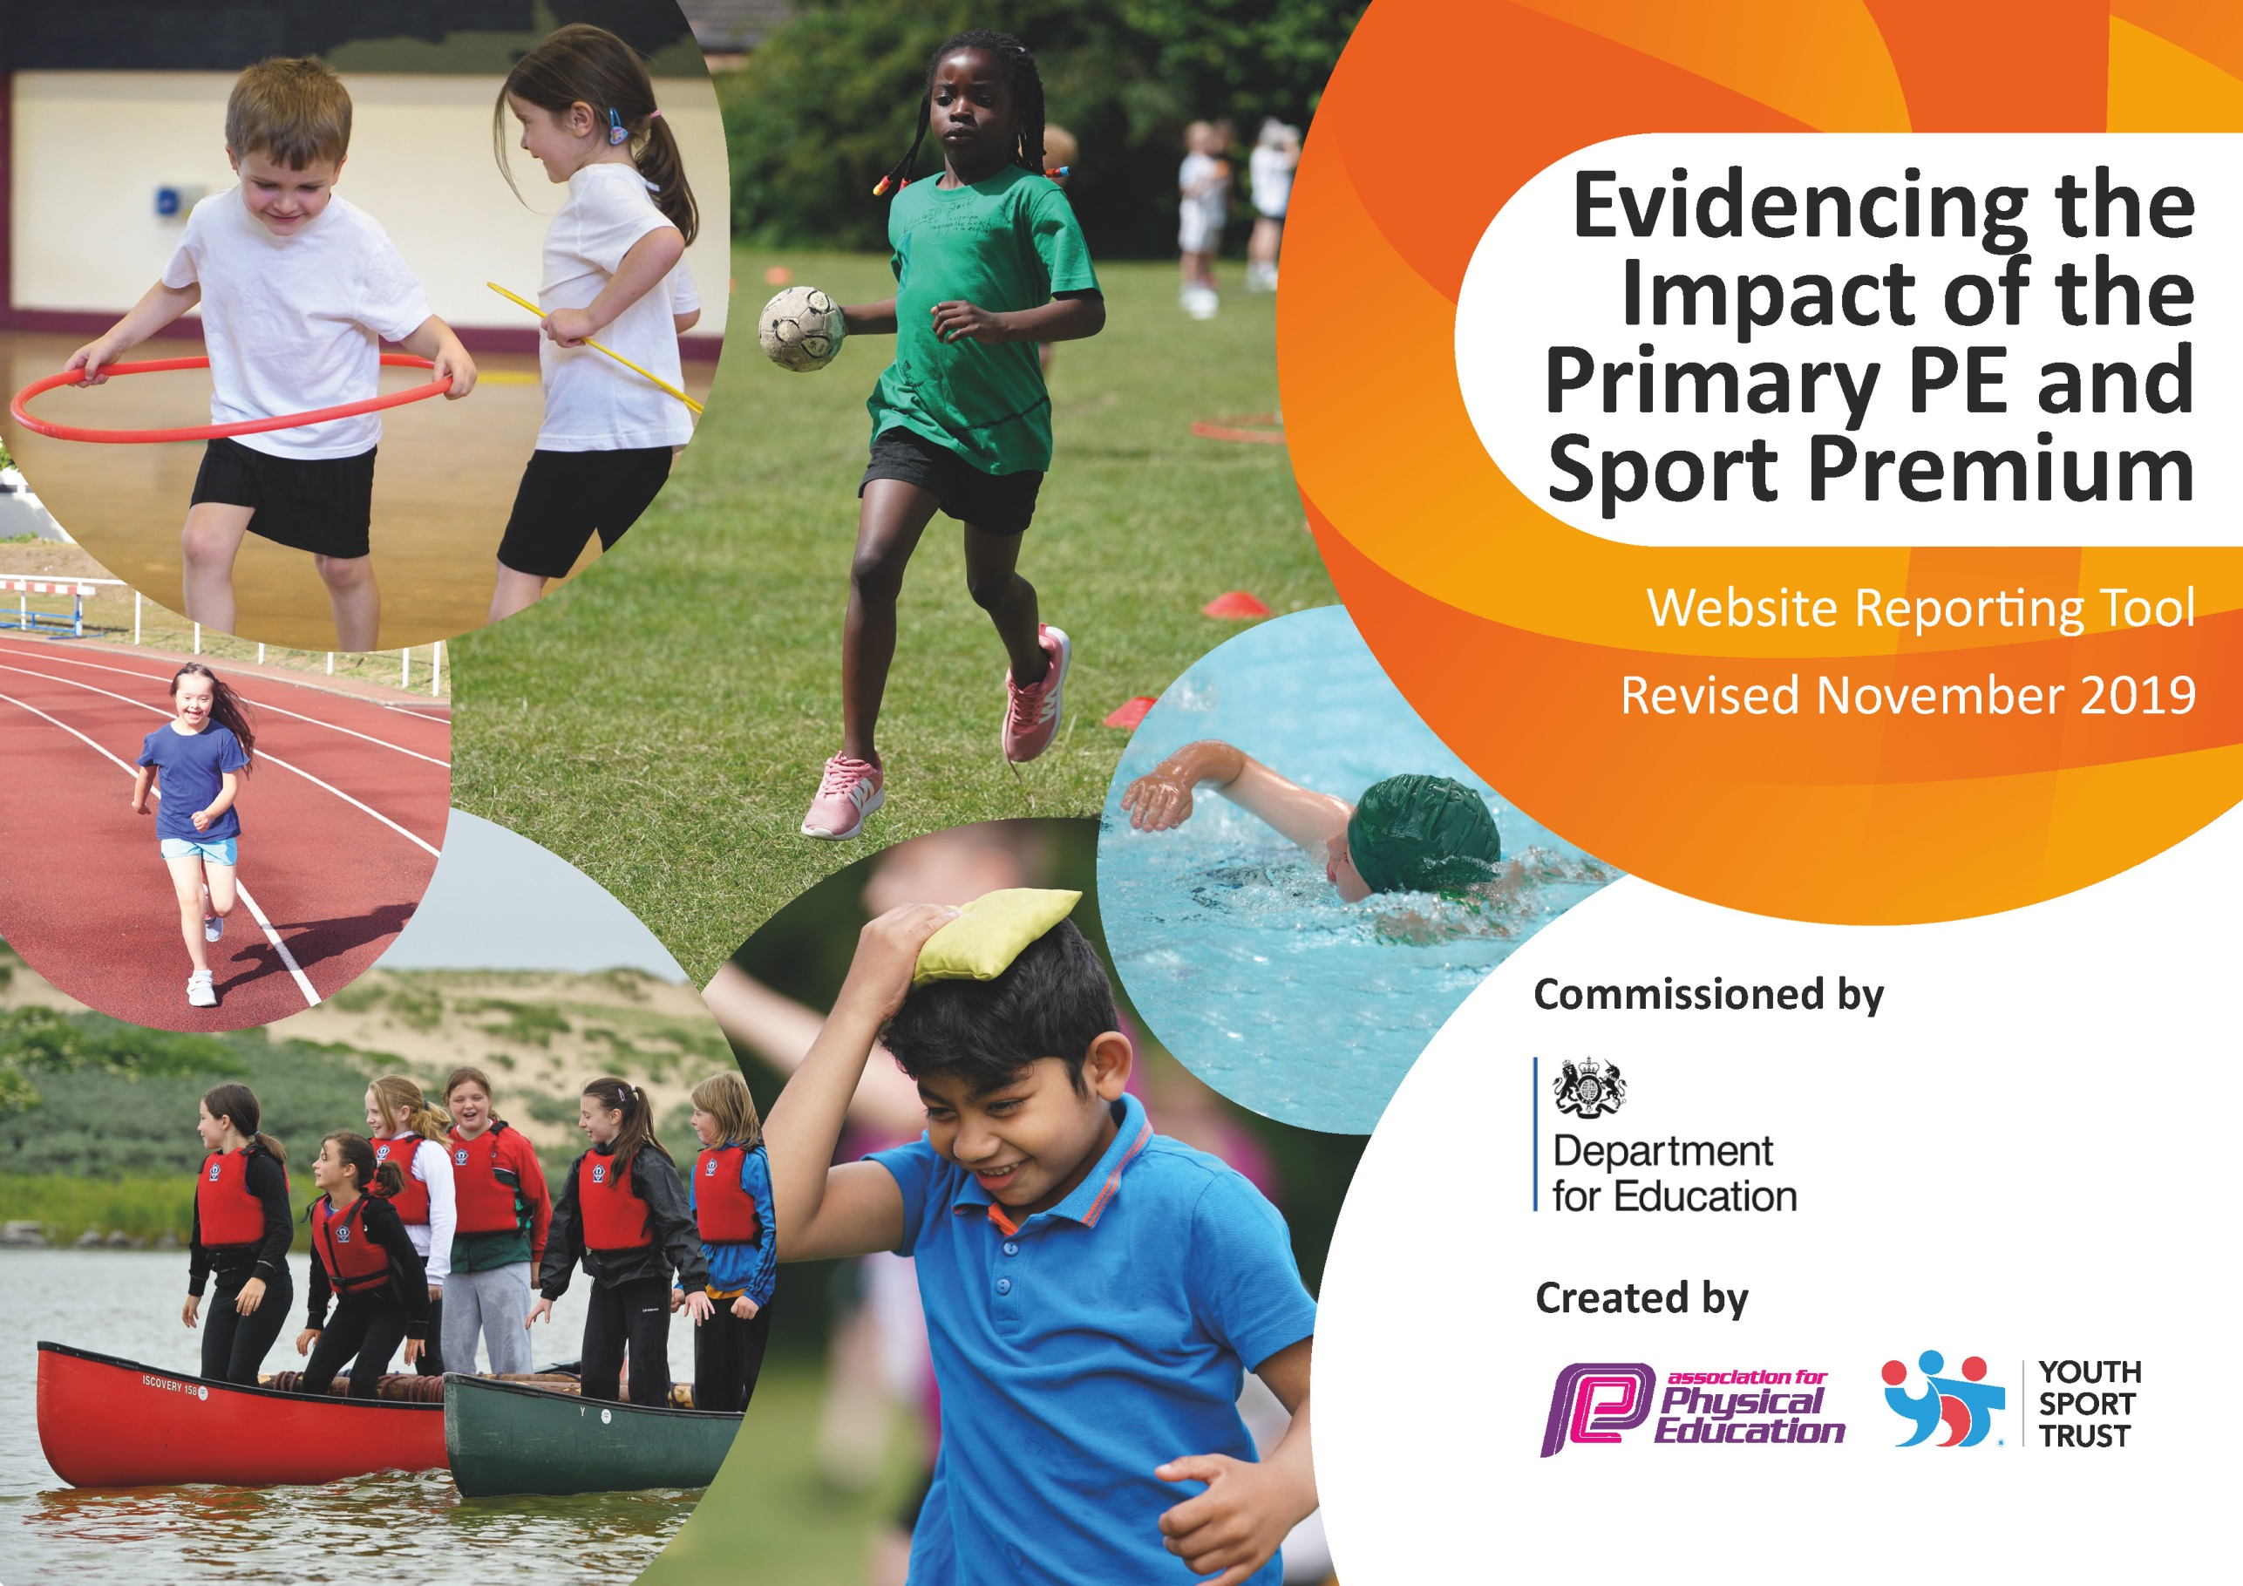
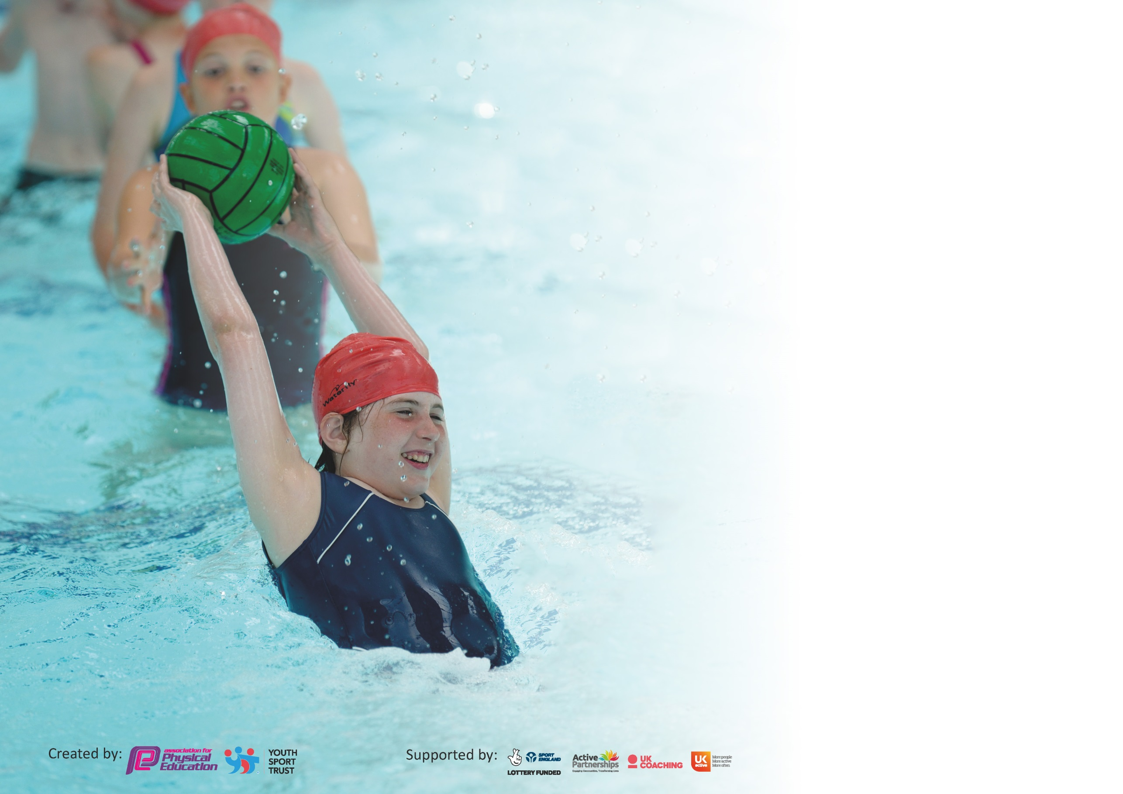

It is important that your grant is used effectively and based on school need. The Education Inspection Framework (Ofsted 2019 p64) makes clear there will be a focus on ‘whether leaders and those responsible for governors all understand their respective roles and perform these in a way that enhances the effectiveness of the school’.

Under the Quality of Education criteria (p41) inspectors consider the extent to which schools can articulate their curriculum (INTENT), construct their curriculum (IMPLEMENTATION) and demonstrate the outcomes which result (IMPACT).

To assist schools with common transferable language this template has been developed to utilise the same three headings which should make your plans easily transferable between working documents.

Schools must use the funding to make additional and sustainable improvements to the quality of Physical Education, School Sport and Physical Activity (PESSPA) they offer. This means that you should
use the Primary PE and Sport Premium to:

- Develop or add to the PESSPA activities that your school already offer
- Build capacity and capability within the school to ensure that improvements made now will benefit pupils joining the school in future years

Please visit gov.uk for the revised DfE guidance including the 5 key indicators across which schools should demonstrate an improvement. This document will help you to review your provision and to report your spend. DfE encourages schools to use this template as an effective way of meeting the reporting requirements of the Primary PE and Sport Premium.

We recommend you start by reflecting on the impact of current provision and reviewing the previous spend.

Schools are required to publish details of how they spend this funding as well as on the impact it has on pupils’ PE and sport participation and attainment by the end of the summer term or by 31st July 2020 at the latest.

We recommend regularly updating the table and publishing it on your website throughout the year. This evidences your ongoing self-evaluation of how you are using the funding to secure maximum, sustainable impact. Final copy must be posted on your website by the end of the academic year and no later than the 31st July 2020. To see an example of how to complete the table please click HERE.

Support for review and reflection - considering the 5 key indicators from DfE, what development needs are a priority for your setting and your pupils now and why? Use the space below to reflect on previous spend and key achievements and areas for development.

Key achievements to date until July 2019: | Areas for further improvement and baseline evidence of need:
- Competitive sports well developed, especially at Year 5 and 6  - Participation in local cluster festivals and tournaments  - Swimming gala to promote swimming at all ages  - Swimming for all children in Y2 and above for 2 short terms each year | - Increase opportunities for sporting competition for children in Y4 and below  - Increase numbers of pupils taking up opportunities for extra curricular clubs  - Ensure all children have the opportunity for active play at lunchtimes

Meeting national curriculum requirements for swimming and water safety.
What percentage of your current Year 6 cohort swim competently, confidently and proficiently over a distance of at least 25 metres?  N.B. Even though your pupils may swim in another year please report on their attainment on leaving  primary school at the end of the summer term 2020. | %
What percentage of your current Year 6 cohort use a range of strokes effectively [for example, front crawl, backstroke and breaststroke]? | %
What percentage of your current Year 6 cohort perform safe self-rescue in different water-based situations? | %
Schools can choose to use the Primary PE and Sport Premium to provide additional provision for swimming but this must be for activity over and above the national curriculum requirements. Have you used it in this way? | Yes – to provide a competitive swimming gala for all children to participate in.

Action Plan and Budget Tracking
Capture your intended annual spend against the 5 key indicators. Clarify the success criteria and evidence of impact that you intend to measure to evaluate for pupils today and for the future.

Academic Year: 2019/2020 | Total fund allocated: £34,997, (includes carry forward of £18,136) | Date Updated: January 2020
Key indicator 1: The engagement of all pupils in regular physical activity – Chief Medical Officer guidelines recommend that primary school pupils undertake at least 30 minutes of physical activity a day in school |  |  |  | Percentage of total allocation:
 |  |  |  | %
Intent | Implementation |  | Impact
Your school focus should be clear what you want the pupils to know and be able to do and about what they need to learn and to consolidate through practice: | Make sure your actions to achieve are linked to your intentions: | Funding allocated: | Evidence of impact: what do pupils now know and what can they now do? What has changed?: | Sustainability and suggested next steps:
Provision of two PE lessons every week in all classes | Every class has two PE lessons each week, taught by class teacher for one and qualified coaches for the second. | £0 – funded through main budget
Improve playground facilities – artificial grass and new netball surface and markings. | Improved facilities for children to play. | £11,800 (from carried forward budget) | Observations at lunchtimes and playtimes show large majority of children are engaged in active play
Increased physical activity at lunchtimes | Provision of extra sports coach at lunchtime twice each week to lead physical activities.
Increase range of physical activity at lunchtime | Training of MDSA team to increase skills in leading physical activities - | £200
Key indicator 2: The profile of PESSPA being raised across the school as a tool for whole school improvement |  |  |  | Percentage of total allocation:
 |  |  |  | %
Intent | Implementation |  | Impact
Your school focus should be clear what you want the pupils to know and be able to do and about  what they need to learn and to  consolidate through practice: | Make sure your actions to achieve are linked to your intentions: | Funding allocated: | Evidence of impact: what do pupils now know and what can they now do? What has changed?: | Sustainability and suggested next steps:
- To increase range of PESSPA being offered to all children  - Raise profile of active play | Provide sports leaders at lunchtimes | £240
 | Provide enhanced range of lunchtime and playtime equipment – specifically ‘Playpod’ type activities.  To include training of staff to enable maximum use of equipment. | £7000
 | Ongoing refreshment of resources and equipment for play and lunchtimes – hoops, balls, skipping ropes etc. | £500
 | Improvement to Hercules Play Equipment - slide | £200
 | Ballet sessions for YR and Y1 | £37.50

Key indicator 3: Increased confidence, knowledge and skills of all staff in teaching PE and sport |  |  |  |  |  |  | Percentage of total allocation:
 |  |  |  |  |  |  | %
Intent | Implementation |  |  |  | Impact
Your school focus should be clear | Make sure your actions to | Funding |  |  | Evidence of impact: what do |  | Sustainability and suggested
what you want the pupils to know | achieve are linked to your | allocated: |  |  | pupils now know and what |  | next steps:
and be able to do and about | intentions: |  |  |  | can they now do? What has
what they need to learn and to |  |  |  |  | changed?:
consolidate through practice:
- All teachers teach PE  - Teachers are supported at clubs by experienced and qualified coaches | Teachers responsible for planning and leading teaching so do not become de-skilled  Parents with specialist skills in hockey and netball support the relevant clubs  Open dialogue about teaching in general – discussions about what goes well and what to improve. | £0  £0 - volunteers
Key indicator 4: Broader experience of a range of sports and activities offered to all pupils |  |  |  |  |  |  | Percentage of total allocation:
 |  |  |  |  |  |  | %
Intent | Implementation |  |  |  | Impact
Your school focus should be clear | Make sure your actions to | Funding |  |  | Evidence of impact: what do |  | Sustainability and suggested
what you want the pupils to know | achieve are linked to your | allocated: |  |  | pupils now know and what |  | next steps:
and be able to do and about | intentions: |  |  |  | can they now do? What has
what they need to learn and to |  |  |  |  | changed?:
consolidate through practice:
Offer a range of sporting activities: | Booking workshops for ‘less mainstream’ activities – skipping and archery.
 | Judo club now offered for children | £0
 | Dance Club – run by professional Dance teacher | £184
 | Offer to children to attend ‘Talent Team’ workshops at secondary schools. | £100
Key indicator 5: Increased participation in competitive sport |  |  |  |  |  |  | Percentage of total allocation:
 |  |  |  |  |  |  | %
Intent | Implementation |  |  | Impact
Your school focus should be clear what you want the pupils to know and be able to do and about what they need to learn and to consolidate through practice: | Make sure your actions to |  | Funding | Evidence of impact: what do  pupils now know and what  can they now do? What has  changed?: |  |  | Sustainability and suggested
 | achieve are linked to your |  | allocated: |  |  |  | next steps:
 | intentions:
Offer competitive opportunities through tournaments and matches.  Increase opportunities for competitive sport in Y4 and below. | Netball, hockey, football, swimming (through the gala), multi sports (KS1), all attended. Small schools tournament for netball and football.  Take part in Chippenham Games and other sports tournaments  Swimming gala for all pupils  Take up any opportunities offered by the Chippenham Sports Partnership.  Contact other local schools to investigate competitive matches / tournaments.  Sports Partnership Subscription  Use administration time to monitor participation |  | £500  £120  £450  £3300  £100

Signed off by
Head Teacher:
Date:
Subject Leader:
Date:
Governor:
Date:

