11 by 11: opportunities to Amaze, Excite and Inspire every pupil

As we start 2020 we are launching an exciting new initiative called “11 by 11”. We have talked with staff, pupils and parents about the experiences that are important for all our children to take part in during their time at primary school. We have then made a commitment to offer all our pupils the opportunity to take part in all eleven of the experiences in the list below before they leave Langley Fitzurse at age eleven.

Experience | Class / Year Group | Values
Learn to save a life | Year 5 & 6 | SERVICE & family
Visit live theatre / enjoy a live musical performance | Year R and 1 | Amazing, Exciting and Inspiring
Grow and cook something (seeds to supper) | Year R and 1 | RESPECT
Stay away from home | Year 5 and 6 | PERSEVERANCE & family
Learn to play a musical instrument | Year 3 and 4 | PERSEVERANCE
Represent the school – in sport, music (choir etc.), maypole, dance festival, etc. | All years | SERVICE
Actively take part in a charity event – running a bake sale to raise money, complete a sponsored challenge, etc. | Year 2 and 3 | SERVICE and family
Visit Malmesbury Abbey for Lifepath, and visit a place of worship for another faith | Year 5 visit Malmesbury Abbey, additional visits in other years | RESPECT
Support the local community – carol singing at a care home, invite older people to lunch, etc. | Year 5 | SERVICE and family
Plant a tree | Year 3 | RESPECT
Start a small business – make £5 grow | Year 4 and 5 | PERSEVERANCE

11 by 11: opportunities to Amaze, Excite and Inspire every pupil

Many of the experiences can be linked to our school values of friendship, respect, truthfulness, forgiveness, perseverance, service and our motto “Amaze, Excite, Inspire”.

Some of these are activities we already offer children, some are new, some expand on what we already do. All are things we believe are important to allow children to develop their understanding of themselves and the community they live in, both locally and more widely.

During their time at Langley Fitzurse the children will take part in many other experiences in addition to the “11 by 11” list. They will have the chance to visit museums, learn from visitors to their classrooms and much more. This list doesn’t limit what we offer but provides a way of making sure all children have the chance to undertake activities we think are particularly valuable.

All the experiences will be offered to all pupils although it may be the case that individuals don’t take up every opportunity. An example might be a child choosing not to attend the residential visit we offer in Year 5 and 6.

Most of the activities are self-explanatory, some are explained a little further below:

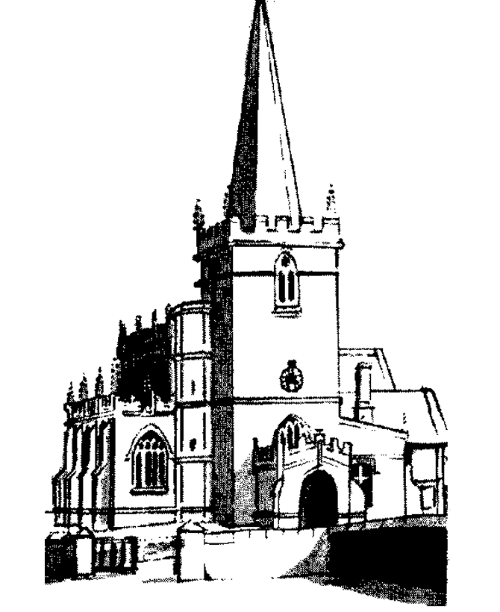
Malmesbury Abbey Life Path is an annual event allowing primary school pupils the opportunity to explore Christianity through the ‘life path’ of a well-known Christian from history with a link to their location and reflect on their response to the story. We’ll also visit other places of worship and learn about other faiths.
Start a small business will use the Virgin Money scheme whereby children receive a loan of £5.00 which they use, working in teams, to design and develop a product or service. The children then decide what to do with any money made after the loan is returned.
Learn to save a life will involve First Aid experts visiting school to teach the children emergency first aid.

