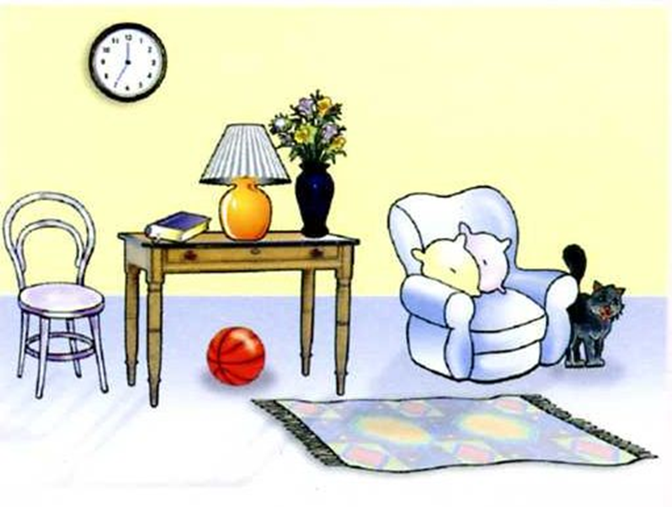
Copy out the sentences in your book and underline the prepositions.
- The chair was beside the table.
- The book was under the bed.
- The clock is on the wall.
- The folder is next to the chair.

Now rewrite these sentences and include adjectives. Can you make up some more of your own?

Copy and complete the sentences.

- On the wall, there is a ______________________.
- There is a white chair ________ the table.
- Under the table, there is a ________________.
- On the table there is a __________, a _____________ and a _______.
- The lamp is between the ______________ and the ______________.
- There are two cushions _________________.
- A black cat is standing _____________________________.

Write about what you can see in the picture using prepositions. Add as many adjectives as you can.

Extension
Rewrite a sentence and change the preposition.

