20200521-Langley Fitzurse Play Pod proposal for FGB
Richard and myself met two representatives from Scrap store before lock down to discuss the options for us to get our own play pod for the school.
Further info and a short video is available here: https://www.playpods.co.uk/
We consulted the school council and obtained their approval.
The project seeks to install and build a wooden shed (3.5mx2.5m) filled with loose parts for the children to play with in imaginative and creative ways. The play pod will be located next to the gazebo and near the kitchen external wall. This is part of the playground renovation project started by Simon.
The costs also include training and a years worth of ongoing support from Scrap store and a comprehensive evaluation/distance travelled report at the end of the year. The training would be for up to 15 staff and would include a level two qualification in play work, support to staff in delivering the play pod activities.
The project seeks to:
- Develop and enhance the strong free play we have currently in school break times.
- Engage in the Scrap store Play Pod process with school staff and management.
- Support and empower the lunchtime staff in taking ownership of lunchtimes and the Scrap store Play Pod.
- Providing lunchtime staff with time for reflection with Play work Mentors at the end of each lunchtime (usually between 5 and 10 minutes)
- Provide a dedicated and appropriate space for training the lunchtime staff each week.
- Commitment to communicating the principles and practices of play to school stakeholders.
- Taking part in a siting survey to enhance play in other areas and not displace other playtime activities when the Scrap store Play Pod arrives.
- Listening to children’s voices about play in your school and feeding this into the scrap delivery process.
- Support a child’s right to play

Cost of the project: -
Pod/storage building (quotes below).
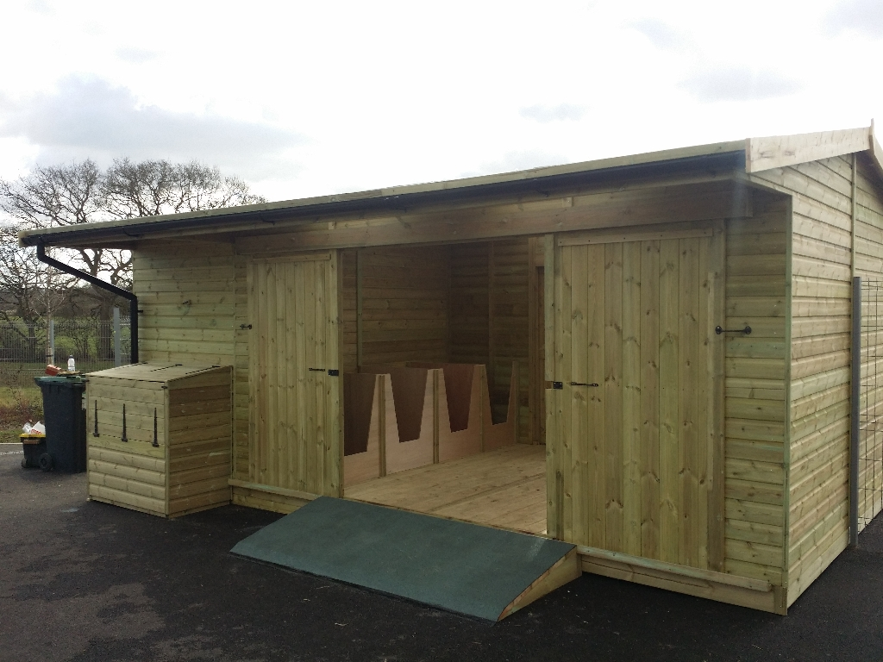

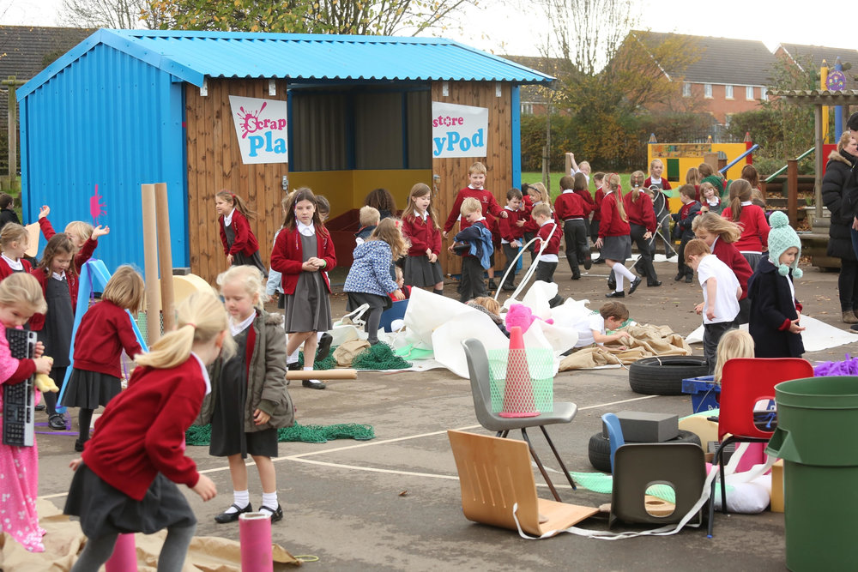
To be paid for from Wiltshire Council- Chippenham Area Board grant and Tesco bags for help funding (£1,166.00) if required.
Funding sought from Chippenham Area Board Grant £1840.00
The PTA chair has provisionally agreed to apply for the area board funding as the school and the board can’t directly apply. An application has been drafted in advance of this meeting.

Timber Tack- £3125+vat (Scrap Store’s suggested provider)
RP sheds- £1840.00
Bulldog sheds and fencing- £2158.00 inc vat
Cost of training, qualifications and support £6,150 +vat. To be paid for from SPG
Cost of scrap refills x 6 over 12 months = £600 no vat. To be paid for from school budget
Total cost of project (Based on accepting RP sheds quote) = £8,590

Obtaining three quotes for the Playpod training is difficult as it is a specialised and “If it is impracticable to obtain three written quotations, the reasons for not doing so should be reported to the governing body”, I have not been able to get three quotes.
This project will fall in the 2020/21 financial year.
The next Chippenham Area Board meeting is 8th July 2020.
A summary of work so far has been sent to Karen for her information.
I seek your support in approving this project at the FGB, I can be contacted on07980658404 if you would like to discuss the project before the meeting.

Thank you,

Huw Solly
Governor-Langley Fitzurse C of E Primary school

