“Ahoy me hearties!”
A man in Suffolk has built a giant pirate ship in his back garden. Tim Jones spent half a year creating the captain's cabin, deck and seven metre mast (more than 3 times the height of a door!)
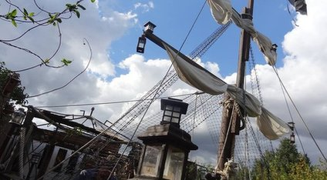
He then added several humorous finishing touches including a toy parrot called Polly and a Jolly Roger pirate flag. Tim said, "I spent every free hour I had and weekends building it. It was a tiring time but now I know it was all worthwhile."
Tim said the idea for the pirate ship came from his themed birthday party. He gathered and used discarded wood to build the pirate ship at minimum cost. Some trees had to be cut down to fit it in.

The unusual garden feature has become well known by locals as the mast can be seen from the road. “It really makes me chuckle every time I walk past,” said a neighbour.
"Everyone loves it," Tim said. "I'd love to make it bigger but I really don't have the room."

- How many months did it take Tim to build the pirate ship?
- Did it cost Tim a lot of money to build the pirate ship? How do you know?
- “The neighbours don’t like the pirate ship.” True or false? Explain how you know.
- What does the writer think about the pirate ship? Explain what word gives you a clue.
- “The pirate ship is large.” True or false? Explain how you know.
- Is Tim pleased with his pirate ship? How do you know?
- Why do you think the title of the article is “Ahoy me hearties!”?

