Key Stage 2 Home Learning Pick ‘n’ Mix Activities
To extend your learning, you can choose to complete as many tasks as you like from the options below.
#MyDearNewFriend  This fabulous new project supported by The National Literacy Trust encourages children to write letters to people living in care homes. Click on the link above to find out how you can take part. | What makes a hero super?  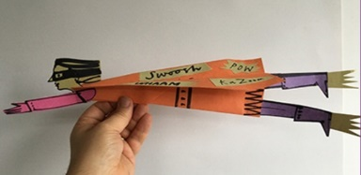  Find out about how artists and authors create superhero characters with the British Library. Then, decide what makes your own hero super and make them using just pens, paper, glue and scissors. | Super Action Comic Maker  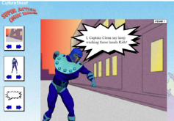  Once you’ve created a superhero, why not design your own comic strip. Choose your heroes and villains and use speech bubbles to give them a voice. Save your new comic strip and upload it to Culture Street’s Gallery for other children to read and enjoy!
Arty Maths  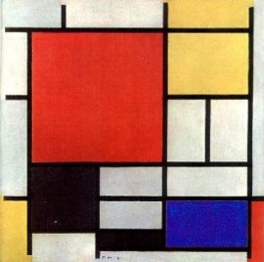  Combine Maths and art this week by learning about the artist Piet Mondrian and re-creating your own version of his pictures following his rules. More information follows the grid below. | Geography Song  Ever wanted to know the continents and oceans of our world? Well fear not, learn them with The Geography Song! There are also some fun activities on the page that link to the song that you might want to do too! | Ready, Steady Cook  Try making Rainbow pizzas using the recipe on this website.  How many different colours can you add to your pizza?  Don’t forget to practise fractions when cutting your slices!
Mindfulness  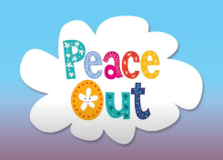  Try some of the Peace Out guided relaxation videos from Cosmic Kids. | Spellings  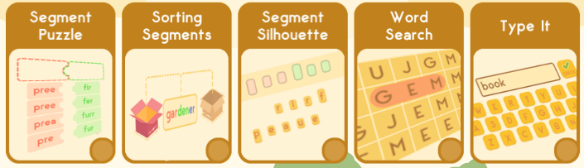  Play games on Spelling Frame to help you practise the spelling words for your year group. | Maths Daily 10  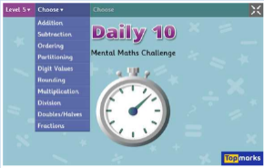  Every day this week, practise your mental maths skills with the Daily 10 question generator.

