Why are we a Church School?

Long before the government provided education for everyone in our country, the Church of England was first to provide education for all, believing that learning could provide a way out of poverty. The local church, St Peter’s, founded our village school in 1856/7.

Our Trust Deeds commit us to preserving and developing the Christian character of our village school, in accordance with the Church of England, and in partnership with St Peter’s Church and the Diocese of Bristol.

The Church of England’s vision for education is ‘Deeply Christian, Serving the Common Good’ educating for wisdom, hope, community and dignity. We believe that Jesus offers life in all its fullness. (John 10:10)

What role does the Diocese have?

Bristol Diocese Education Team gives expert support, advice & training for staff and governors. They provide an extra inspection called SIAMS (Statutory Inspection of Anglican and Methodist Schools) which asks:

How effective is the school’s distinctive Christian vision, established and promoted by leadership at all levels, in enabling pupils and adults to flourish?
What will you notice?

As a parent, carer, pupil, visitor or member of staff you will find Langley Fitzurse aims to offer the best academic education, as other schools would, but we also seek to develop & nurture our pupils’ character in a special and distinctive way.

As a church school, the vision and values that underpin daily life at Langley Fitzurse arise from the Christian faith. Friendship, Respect, Truthfulness, Forgiveness, Perseverance and Service inform every aspect of our school community life. These values enable us to live well together and help develop a moral and spiritual awareness in each person.

Our Governors, Headteacher and staff are supportive of the Christian character of our school. We hold a relevant & inspiring daily act of worship, festival services in church, we have & value our established pupil Worship Council. We also provide opportunities for celebration, spiritual reflection and prayer.

‘Because we are quite a small school, we have a lot of friendship and kindness between us. We believe that God is love, and because God cares for us all, we care for him, for others and for ourselves.” Martha, Y6 Pupil
You are welcome, whoever you are,
from whatever sector of society
you come from and whatever your abilities and talents may be.

We are proud to be a Church of England school. However, a church school is NOT a faith school. It was established for our local community, and we have a strong ethos of openness, welcome and service to all, whether you have any faith or none.

What we don’t do, because we are inclusive

- You do not have to be a Christian or a churchgoer to be allocated a place or work in our school

- You are very welcome to attend church, but it is not a requirement

- In RE we learn about all faiths, respecting differences because this is important so we can live well together

- Pupils and staff will be given opportunities to take part & lead worship, but without compromising their own beliefs.

If you choose to attend our church school, the Christian ethos permeates all we do. We hope that all members of our school community will join in with Collective Worship and RE, however, parents do have the right to withdraw their children if they wish. Please come and discuss this with the head teacher.

St Peter’s Church, Kington Langley
and the Draycot Benefice

The village school was built and St Peter's Church established for the local community at the same time in the mid 1800's. The school and the church, which is just across the road, continue to have a close relationship.

Today there is an active partnership with strong and supportive links:

- We pray for each other
- Members of the local church Ministry team visit the school & regularly lead Collective Worship and support RE
- Pupils visit St Peter’s Church to enhance many areas of the curriculum
- The Church organises ‘Experiences’ for pupils to explore church festivals
- The school holds services in church, planned & led with the Draycot team
- Foundation governors attend Parish Church Council meetings
- The Draycot team offers pastoral support to staff and school families
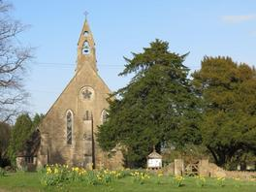

https://draycot.weebly.com
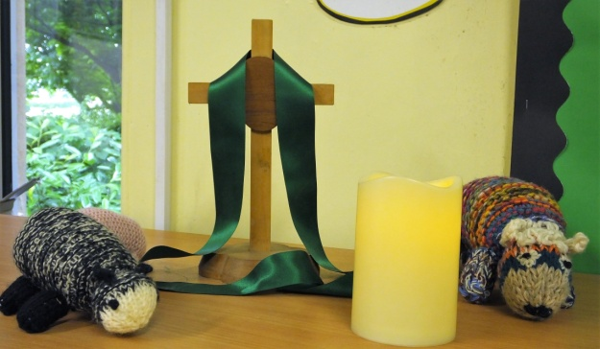

We hope that this leaflet helps to explain why we believe Church Schools are so special, and the advantages they can offer to pupils in terms of values & personal development.

We would be grateful to receive any feedback from you about how we can continue to develop our distinctive Christian character to support our school community.

You are welcome to contact the head teacher directly, or speak with one of our Foundation Governors, who are ready to listen.

OUR FOUNDATION GOVERNORS

Mr David Bloomer
DBloomer@langleyfitzurse.wilts.sch.uk

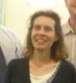
Mrs Harriet Wilkinson
HWilkinson@langleyfitzurse.wilts.sch.uk
Langley Fitzurse
Church of England
Primary School

‘Let us help each other to love others
and do good’
Hebrews 10:24

What is great
about Langley Fitzurse being a
Church School?

We are an inclusive, friendly church school with a family feel.
Our purpose is to Amaze, Excite & Inspire confident, happy and resilient children within our community where everyone can reach their full potential.

