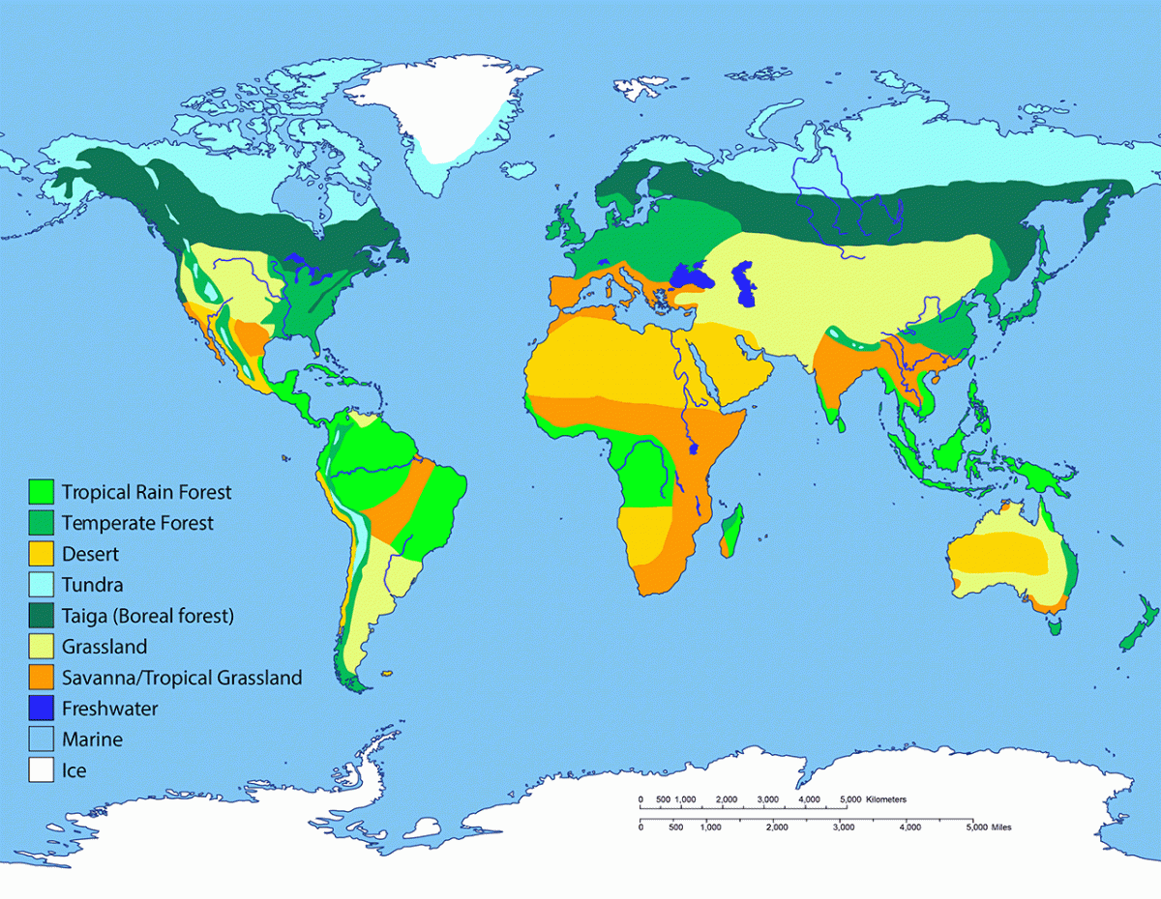

***PE***

* find out about the most popular **sports** and then try them out at home
* learn a traditional **dance**

***Music***

* discover which instruments are used in **traditional music/songs.**
* if you play an **instrument**, learn a short piece of music from your country
* find out which **pop groups** are popular today – write a review of one of their songs

***DT***

* explore the **food** your country is famous for. Can you try and **cook** a simple dish?
* build a model of a **famous landmark** ora **traditional house**
* find out about the major **landforms**, **landmarks** and/or bodies of **water**

***RE***

* what are the major **religions?** What do they believe?

***DT***

* explore the **food** your country is famous for. Can you try and **cook** a simple dish?

***RE***

* find out about the major **landforms**, **landmarks** and/or bodies of **water**

***OTHER***

* learn a few key words or phrases in the **language**(s) of your country e.g. hello/goodbye
* discover if there are any strange **customs, laws or traditions.** What **top tips** would you give to travellers?
* include any other **interesting facts** you have discovered!
* are there any well-known **companies** or **brands** from the country?
* find out about the major **landforms**, **landmarks** and/or bodies of **water**

***Science***

* investigate **animals** that are native to your country. How have they adapted to their **habitat**? Describe their **food chain/web**?
* are there any **famous scientists** or **inventions** from your country?
* find out about the major **landforms**, **landmarks** and/or bodies of **water**

***Maths***

* find out about your countries **currency** (money). What is the exchange rate? How much do things cost compared to the UK?
* draw a graph to show the **temperature**

and/or **rainfall**

* how many **miles** is it from your home to your country? How much would it **cost** to get there?
* Look closely at the flag – is it **symmetrical**? What else do you notice about its design?

***History***

* what **key events** have taken place in the history of your chosen country?
* does your country have a **royal family, ruler** or **presidents**?
* which **famous people** are connected to your country?

***Geography***

* show on a **map** where in the world your country is located
* locate the **capital city** and discover some key facts about it
* find out about the major **landforms, landmarks** and/or bodies of **water**
* describe the **climate and weather**
* find out about the country’s major **exports** (things they provide to the rest of the world)

***English***

* design a **travel brochure** for your country to persuade people to go there and inform them of the major attractions
* write a **poem** about a feature of your country e.g. a waterfall, a city, a volcano…
* write a **newspaper report** about a key event in the country e.g. an Olympic games taking place, a space shuttle launch…
* write a **report** about an animal that lives in your country
* create a **story** based in your country – include key details such as actual places, typical names, foods, weather etc.

***PHOENIX: Country Project***

***Choose a country of your choice to research.***

* ***Decide how to present your work e.g. posters, leaflets, drawings, PowerPoint, photos or videos…***
* ***Try to include a range of subject areas - of course, you can also include other ideas that are not listed here!***

***We would love to see your learning via SeeSaw or you can send it in to our Phoenix email account.***

***ART***

* design **clothes** suitable for the climate or based on traditional clothing
* draw/make the **flag** using materials of your choice
* create a piece of **art** showing an aspect of your country e.g. the countryside, a city scene, a traditional house…
* find out about the major **landforms**, **landmarks** and/or bodies of **water**