Victorian Children at Work

Life was very different for Victorian children – if you were poor you went to work at a very young age. It was tough work and often very dangerous too!

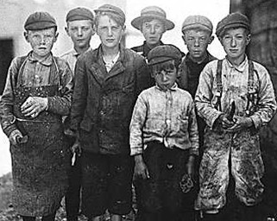

TASK: Research what it was like to be a poor Victorian child at work. Complete the activity sheets on the school website or present the information in another way e.g. PowerPoint, leaflet, video – you choose!

You can do your own research but the following clips will be a good starting point:

Factories in Victorian Britain:
https://youtu.be/iKcSXqUrMGU

Children working in coal mines:
https://www.bbc.co.uk/bitesize/clips/z73b4wx

Children working in textile mills:
https://www.bbc.co.uk/bitesize/clips/zsdw2hv

