Bus Stop Method: Quick Guide
The bus stop method, also known as short division, is a technique taught once children are confident with the chunking method of division.

Why is the bus stop method used?
The bus stop method is significantly quicker and more efficient than chunking, but requires estimation skills and a thorough understanding of the relationship between multiplication and division.
The bus stop method is great for children learning to divide bigger numbers by multiple-digit numbers.

How to do the bus stop method
The bus stop method can seem confusing at first. Here, we will break down a simple three-digit number division problem using the bus stop method.
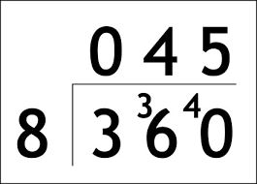
- How many 8s are there in 3? Zero, so above the 3, we write a zero.
- As the 3 hasn’t been used, we move it over to the 6.
- Now we see how many times 8 goes into 36 - 4 times, so we write this above the 6.
- 8 into 36 leaves a remainder of 4, so now we move this remainder over to the next number, which in this case is zero.
- Finally, we see how many times 8 goes into 40. This gives us 5, which we again write above the zero
- If your problem leaves a remainder at this stage, simply leave it as a remainder in the answer.

The bus stop method in the national curriculum
As mentioned previously, the bus stop method is generally taught after chunking, as it is significantly more challenging. As a result, children will most likely encounter it in upper Key Stage 2 / Years 3-6.

Why is it called the bus stop method?

This method is also known as short division. Once children have mastered this, they can move on to long division.

Need further examples or support?
Visit https://thirdspacelearning.com/blog/guide-division-for-kids-explained/

