5 Pillars of Islam

Watch the video on https://www.bbc.co.uk/teach/class-clips-video/religious-studies-ks1-the-five-pillars-of-islam/zv84jhv

Complete the table below about the 5 different pillars of Islam. You made need to do some more research online using a safe search engine such as ‘kiddle’.
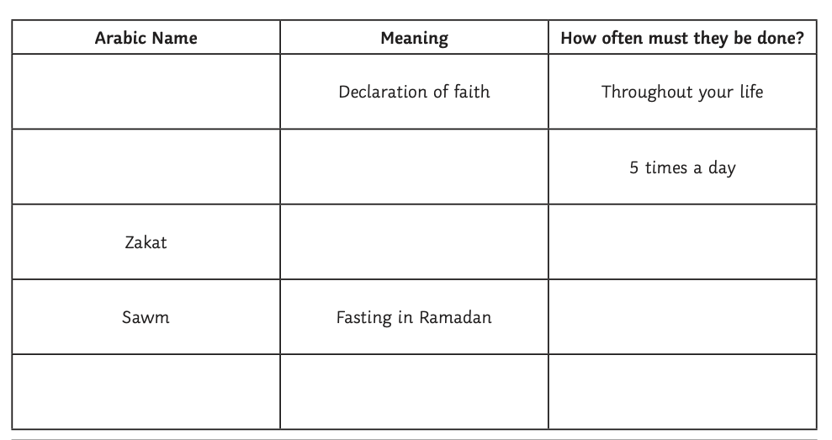

What other interesting facts did you find out?

