Government guidance on the autumn term – advice and support

Last week the government issued guidance on how schools can prepare to open for all pupils from September 2020.
Please see below a number of helpful points to consider as you prepare for the autumn term.

Contents
- The Recovery Curriculum
- Learning and Development requirements for EYFS
- Supporting staff in vulnerable groups to return to the workplace in September
- Summary of Transition and Anxiety Guidance
- Transport to Schools from September
- Promoting walking & cycling
- Readiness for online learning- July 2020- Blended Learning; A working documents
- Maths and English curriculum support – reopening of schools – curriculum support for September 2020
1. The Recovery Curriculum – Resources and Planning
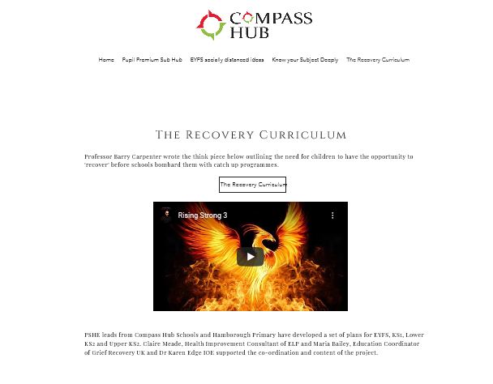
The Compass Hub via Challenge Partners have put together 5 weeks of planning and resources for EYFS to year 6 to support schools . https://www.compasshub.net/the-recovery-curriculum
The plans and resources mirror the 5 stages of a Recovery Curriculum and for each week are divided into EYFS, KS1, lower KS2 and upper KS2 and also have some year specific resources:
Week 1 – Relationships
Week 2 – Community
Week 3 – Transparent Curriculum
Week 4 – Metacognition
Week 5 - Space
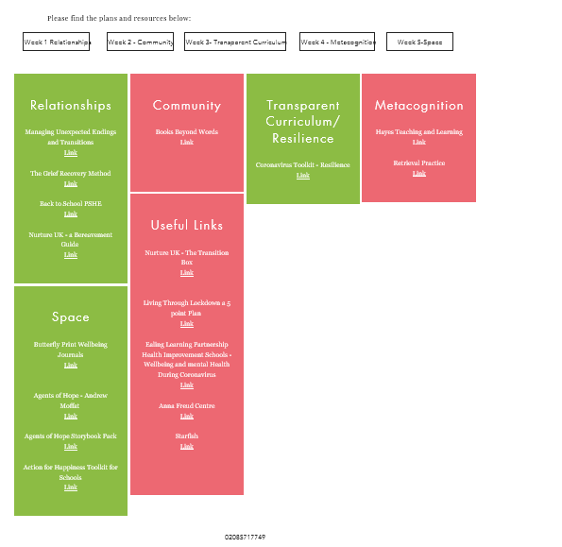

Professor Barry Carpenter has produced a series of podcasts around the Recovery Curriculum which are worth listening to
https://barrycarpentereducation.com/tag/recovery-curriculum/

2. Learning and Development requirements for EYFS
Following the amendments to the EYFS from 24 April, early years settings only need to use reasonable endeavors to deliver the learning and development requirements set out in the EYFS. We understand that these are exceptional circumstances and the priority at this time is keeping children safe and well cared for. As far as possible, children should benefit from a broad range of educational opportunities.
For children in pre-reception settings, practitioners may focus at this time on the prime areas of learning, including: communication and language, personal, social and emotional development (PSED) and physical development. For children in reception year, teachers should also assess and address gaps in language, early reading and mathematics, particularly ensuring children’s acquisition of phonic knowledge and extending their vocabulary. For nursery settings and Reception, consider how all groups of children can be given equal opportunities for outdoor learning
https://www.gov.uk/government/publications/coronavirus-covid-19-early-years-and-childcare-closures/coronavirus-covid-19-early-years-and-childcare-closures#attendance

Use of outdoor space for EYFS
Settings should maximise use of private outdoor space. Early years providers may take small groups of children to outdoor public spaces, for example parks, provided that a risk assessment demonstrates that they can stay 2 metres away from other people at all times. This should be restricted to small groups and should be done in line with wider government guidelines on the number of people who can meet in outdoor public places. Providers should not take larger groups of children to public outdoor spaces at one time.
https://www.gov.uk/government/publications/coronavirus-covid-19-early-years-and-childcare-closures/coronavirus-covid-19-early-years-and-childcare-closures#attendance
This therefore does allow you to work with small group to explore the local environment and carry out activities such as ‘welly walks’ within the local community

Extra-curricular provision
Schools should consider resuming any breakfast and after-school provision, where possible, from the start of the autumn term. We recognise that schools may need to respond flexibly and build this up over time. Such provision will help ensure pupils have opportunities to re-engage with their peers and with the school, ensure vulnerable children have a healthy breakfast and are ready to focus on their lessons, provide enrichment activities, and also support working parents.
https://www.gov.uk/government/publications/actions-for-schools-during-the-coronavirus-outbreak/guidance-for-full-opening-schools
Wraparound providers which are registered with Ofsted or with a Childminder Agency and run before and/or after school clubs on school premises or in early years settings, and can ensure they follow the safe working guidance, are able to operate.
The Prime Minister announced on 23 June that from 4 July, as part of Step 3 of the government’s recovery strategy, wraparound care providers operating from other premises will be able to open. Protective measures guidance has been published to support these providers.
https://www.gov.uk/government/publications/coronavirus-covid-19-early-years-and-childcare-closures/coronavirus-covid-19-early-years-and-childcare-closures#attendance

3. Supporting staff in vulnerable groups to return to the workplace in September

Clinically extremely vulnerable staff

People who are clinically extremely vulnerable are at high risk of serious illness from coronavirus (COVID-19) infection and are the group who will have been sent a letter advising them to 'shield'. As the prevalence of COVID-19 within communities in England has continued to decline, the Government has announced planned changes to shielding advice.

The changes, likely to come into effect on 1 August 2020, include the advice that staff who have been shielding can return to workplaces, if they cannot work from home, as long as their workplace is COVID-secure and they will be able to stringently social distance.

The government has promised more detailed advice as the changes come into effect, however it is expected that the guidance will maintain that those who can work from home should do so. This will not be applicable to most school staff, but where a role may be conducive to home working (for example administrative roles) you should consider whether the role can be adapted to enable this.

Where roles cannot be undertaken from home we know that returning to the workplace is likely to cause concerns for those in the extremely high-risk group. The first step will be for headteachers to review with individual staff whether strict social distancing can be maintained while performing their normal role or duties, and whether any changes can be made to enable this.

Where concerns remain about the ability to maintain strict social distancing an individual risk assessment should be undertaken. For schools and academies who purchase the Wiltshire HR Advisory Service you can access a template COVID personal risk assessment form on the HR advisory area of Right Choice. For those schools and academies who purchase the council’s Occupational Health Service support in completing these risk assessments can be accessed by emailing occhealth@wiltshire.gov.uk.

Wherever possible the aim should be to support staff to return to a safe and suitable role however if, following a comprehensive risk assessment of all work duties and locations, it is judged not possible to provide a safe working environment for clinically extremely vulnerable employees, and no other options such as homeworking are suitable, then staff should not be expected to return to their workplace. The current guidance is that staff in this position should remain on their normal pay - however this will be kept under review.

Staff who live with or care for those who are clinically extremely vulnerable

Staff who live with or care for those who are clinically extremely vulnerable can attend the workplace but should be supported to follow stringent social distancing and hygiene measures and head teachers should try as far as practically possible to accommodate additional measures to support this.

Staff with other vulnerabilities

Staff may have concerns about attending work due to a number of factors including health, age, gender and ethnicity. School and Academies can use the Staff Risk Assessment provided by Wiltshire Council on the public health pages on Right Choice to support discussions around the level of risk and appropriate mitigation.

In many cases anxieties may be able to be overcome by listening to and involving staff in putting in place measures that support them to feel safe.

For schools and academies who purchase the Wiltshire HR advisory service you can access a template COVID personal risk assessment form on the HR Advisory area of Right Choice. For those schools and academies who purchase the council’s Occupational Health Service support in completing these risk assessments can be accessed by emailing occhealth@wiltshire.gov.uk.

Supporting documents:

We are updating the risk assessment document and FAQs to reflect the changes due to take effect from 1 August and will circulate these shortly.

These will also be kept under review and will be updated over the summer as further national guidance is issued.

4. Summary of Transition and Anxiety Guidance
The most important way to support the wellbeing, engagement, and attendance of pupils will be to adopt a whole school approach that focuses on emotional and social skills, such as the Trauma Informed Approach, which identifies the following key areas to promote:
A sense of calm, a sense of safety, a sense of collective efficacy, social connectedness, promoting hope
Although there are many ways to ensure schools promote these areas, top tips include:
- Prioritising quality relationships between adults and young people. Extended tutor times, check ins, and adults modelling the sharing of their own feelings will all be important.
- Encouraging belonging and a sense of community through whole class, whole year group, and whole school shared activities or projects.
- Creating safety through clear expectations, routines, and structure
- Allowing regular time for the sharing and processing of lockdown experiences. Tutor time, peer group discussions, and circle times will be important
- Encouraging prosocial behaviour and projects that make a meaningful contribution to both the school and wider society
There are a number of resources which explore these basic points further which have already been signposted to you, including
- Moving On: Transition from Primary to Secondary (available on Right Choice)
- Promoting Positive Transitions during and after the COVID-19 crisis by Wiltshire EPS
- COVID-19 response and recovery: Maximising the impact of Mental Health Support Teams produced by NHS and DfE
- Tools for Teachers Covid-19 Edition, available currently free from the SEND Gateway, produced by the Autism Education Trust
- Wiltshire Emotional and Mental Health Support flow chart
Outside Agency Support
In addition to the all-important whole school approach, there are a number of outside agencies that will provide support to schools, families, and young people on return to school. These include SEND and Inclusion teams, Mental Health Support Teams, School Nursing, and CAMHS. Please see the attached Wiltshire Emotional and Mental Health Support document.
All the Inclusion teams are currently offering direct support for parents via the Request for Remote Consultation
The Inclusion teams’ Covid consultation offer is in the Right Choice section Service Directory for Schools. There are also some useful resources within the team areas.
Educational Psychology offer
In order to provide a responsive and flexible service to support schools as the majority of pupils return to school, the EP service will be seeking to operate differently in the coming year. Specific details of this will be out before the end of term.
5. Transport to Schools from September

Following on from the issue of the government’s guidance for full opening of schools and FE establishments on the 2nd July, it is worth summarising the implications on how students will attend establishments on both transport provided by Wiltshire Council and the general use of public transport. Further, specific guidance on transport to educational establishments is expected to be made available by the government during the week of the 6th July, whereby Wiltshire Council will provide a much fuller set of guidance to educational establishments, parents and transport providers.

Students travelling on dedicated school/college transport organised by Wiltshire Council

- From September there will be no requirement for social distancing to be in place on dedicated home to school transport, as:
- the overall risk to children from coronavirus (COVID-19) is low,
- they do not come into contact with the general public on home to school transport
- home to school transport often carries the same group of children on a regular basis, and those children may also be together in school.

- It will not be realistically possible to provide transport in year group bubbles, as this is geographically prohibitive. Segregation of children by age on school buses is also likely to be difficult to enforce, at least initially, but in practice often occurs organically with the youngest age groups occupying the front, through to older students to the rear
- Where schools and colleges are considering changing their opening and closing times, they should be aware that many buses are often scheduled to perform more than one journey in the morning and the afternoon. It is therefore likely that most school buses will need to continue operating at the times they did, pre coronavirus.
- Although government guidance suggests that schools and colleges may wish to consider staggered opening and closing times, we will only be able to provide transport once in the morning and once in the afternoon. Therefore, if schools and colleges wish to operate staggered opening and closing times they will need to make provision themselves for students once they arrive on site and also at the end of the day.
- Local authorities remain under a statutory duty to provide free home to school transport for all eligible children
- Wiltshire Council will complete all relevant risk assessments for home to school transport and, where necessary, ensure that transport providers do the same
- Whilst social distancing is not required on dedicated school buses, school and college transport will be operated, as best it can, on the basis of the same “systems of control” that educational establishments are required to work to
- There is no requirement for drivers, passenger assistants or students to wear face coverings on dedicated school buses.

Students travelling on public transport

The government have said that at this point in time, social distancing on public transport remains in place and will do so into the start of the September term. The current requirement is that all passengers should wear a face covering and be at least 1m plus from another passenger. Even with a reduction to 1m plus, this still does not increase capacity on public transport a great deal and the standard single deck public bus will only be able to carry a maximum of 10 passengers. Because of this, Wiltshire Council along with all local authorities nationally, are considering how best to deliver transport for those pupils who use public transport considering some were previously full at peak times and very few spare vehicles and drivers are likely to be available. This means we have a responsibility to consider how all students using public transport can be transported and not just those who are eligible under the councils scheme. Therefore, there will be a need for council staff to work closely with your representatives over the summer months.

This will likely affect smaller pockets of our educational community, but mainly secondary schools and FE establishments where students use public buses to get to their place of education.

Further advice on how this issue will be addressed will be made available before the end of this term.

6. Promoting walking & cycling
Develop and action a school travel plan via the Modeshift STARS Education platform www.modeshiftstars.org – free to use for all Wiltshire schools, includes case studies from around the country and links to the National School Travel Awards
Provide information on safe routes to school – maps are good! (New online resource due to be launched by Modeshift soon)
Work out how far you can walk in 5/10 minutes and create a ‘no-car zone’ – maybe incentives for those who regularly ‘park & stride’ from outside the zone? (Promote walks in terms of time taken, rather than distance – most of us have no idea how far things are and what that means in real terms!)
Give regular reminders (and practice) about ‘Stop, Look, Listen and Think’ and holding hands for younger children and the Green Cross Code for older pupils.
Promote walking and cycling through staff as role models, share stories on social media, set challenges such as scavenger hunts, photo opportunities etc.
Provide secure cycle and scooter storage, protected from the weather if possible. Consider how this will be safely accessed by pupils at peak times.
Organise a cycle buddy or cycle train scheme for older students (like a walking bus, but with bikes!) – led by an experienced/confident rider who knows the route.
Offer Bikeability training – Wiltshire Council offer subsidised training for Year 6 pupils and above. We are available to deliver now, through the holiday if venues available, and from September in schools, although restrictions apply to our usual delivery format)
Offer Scootability training for pupils in Years 1-6 – basic skills and responsible behaviour.
Offer Walk Safe pedestrian training for Years 1, 3 and 6 (free).
More information about all our training is on the RightChoice platform.
Include information about travelling to school on your website, in your induction information and in regular communications to parents. Celebrate the positive stuff, not just the complaints about parking!

Links (also on our Right Choice resources page)
The Bikeability Trust has good videos on their website with advice for families: https://bikeability.org.uk/cycle-more/family-cycling/essential-cycling-skills-for-families/
Cycling UK have videos and advice for all cyclists: https://www.cyclinguk.org/advice-beginners
Living Streets provide resources for schools to promote safe walking: https://www.livingstreets.org.uk/walk-to-school
BrightKidz are a Social Enterprise offering advice on walking, scooting and cycling initiatives, and also products to purchase to promote walking, cycling and road safety https://brightkidz.co.uk/
THINK! Road Safety – the Department for Transport’s resources for teaching children aged 3-16 https://www.think.gov.uk/education-resources/
Dorset & Wiltshire Fire and Rescue have put together resources for KS3-5 on road safety during and after COVID-19 https://www.dwfire.org.uk/education/road-safety-education/
7.
Readiness for online learning
July 2020
BLENDED LEARNING – A WORKING DOCUMENT
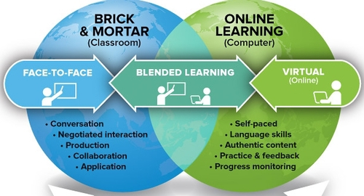

Contents
- Background
- What is blended learning?
- What does good blended learning look like?
  - DfE Guidance (2 July 2020)
  - Support Offer
- Judging the Quality of online learning in your school:
  - Questions for heads and leaders
  - Questions for governors
- Information for teachers
- Questions for teachers
- Case studies
- Synopsis of research

Background

Following lockdown at the beginning of the pandemic, schools devised and delivered learning through a combination of home learning and teaching in school. With the publication of the DfE document “Guidance for full opening – schools” published on 2 July 2020 (https://www.gov.uk/government/publications/actions-for-schools-during-the-coronavirus-outbreak/guidance-for-full-opening-schools), now is the time to reflect on the quality of our home learning and think about how it dovetails with the learning that will now be going on in the classroom from September onwards. There is a clear expectation from the guidance that schools will have “the capacity to offer immediate remote education” should it be needed for a group, an individual or for the whole school.

This is a working document containing ideas, suggestions, summaries of research and questions you can ask yourselves to assess and develop the quality of your current home learning approach into a blended learning approach that can be activated at short notice. If you have any suggestions, ideas, examples of what works well or a narrative around how you have developed systems over time, please do get in touch via your Regional Lead and we can add to the document over time.

It should be acknowledged that many schools will have kept their home learning offer under review and will already have planned how to blend this with in-class learning as a wider number of pupils have returned to school. It may be that you are ready for September through the work you have already done. If this is the case, please do share your ideas with us via your Regional Lead.

The purpose of this document is to support you in your thinking and NOT to add an extra job to your to do list. Every school is different and will need to adapt to its own circumstances.

What is blended learning?

“Blended learning is an approach to education that combines online educational materials and opportunities for interaction online with traditional place-based classroom methods”.
How best can you link what is happening in the classroom with what is happening at home?

Now is the time to consider how you can adapt what you already have in order for it to be fit for purpose for the revised DfE expectations for September 2020.
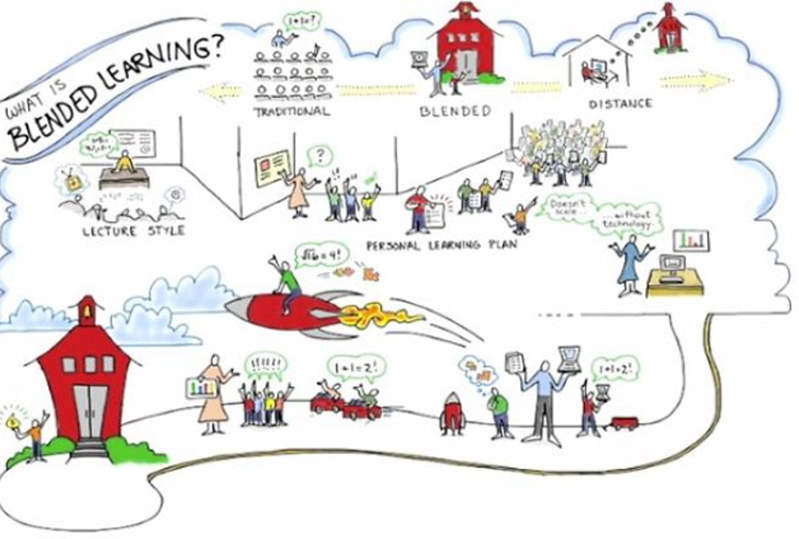

What does effective blended learning look like?

A well-planned, well thought-through in-class curriculum, focusing on critical learning material that can be delivered in chunks each week, supported by accessible home learning activities that reinforce the week’s (or recent) learning. Pupils who cannot currently attend school will not be disenfranchised in their learning.

Suggested process:
- Review your home learning offer and evaluate its effectiveness.
- Prioritise those curriculum areas that are critical to learning and best taught in the classroom setting and design home learning to support and reinforce this learning.
- Identify how these critical areas can be taught at home to pupils who are unable to attend school.
- Agree how this looks, minimising/sharing workload, so that all staff understand their role.
- Review and evaluate regularly.

Research highlights the following are important for effective home learning:
- Home learning builds on prior learning – in blended learning, this can build on immediate prior learning
- Regular social contact is essential – between school adults and pupils and between pupils
- Teachers’ evaluation of an individual’s learning needs to be regular, leading to regular feedback and dialogue
- 1:1 regular feedback is effective, group feedback is not as effective although there is a place for it

DfE guidance for full opening of schools (2 July 2020)

https://www.gov.uk/government/publications/actions-for-schools-during-the-coronavirus-outbreak/guidance-for-full-opening-schools

The guidance is clear that schools should develop their remote and blened learning provision ready for September 2020; the following paragraphs refer to remote learning:

Remote education support
‘Where a class, group or small number of pupils need to self-isolate, or there is a local lockdown requiring pupils to remain at home, we expect schools to have the capacity to offer immediate remote education’. Schools are expected to consider how to continue to improve the quality of their existing offer and have a strong contingency plan in place for remote education provision by the end of September. This planning will be particularly important to support a scenario in which the logistical challenges of remote provision are greatest, for example where large numbers of pupils are required to remain at home.
Schools will also need to include the remote learning contingency plan in their business continuity plan.
In developing these contingency plans:
- use a curriculum sequence that allows access to high-quality online and offline resources and teaching videos, and that is linked to the school’s curriculum expectations
- give access to high quality remote education resources
The Oak National Academy is producing a full curriculum for primary, secondary and special schools for 2020/2021 with accompanying video lessons: https://www.thenational.academy/# These could be used by schools wholly or partially for their online and or blended offer.

- select the online tools that will be consistently used across the school in order to allow interaction, assessment and feedback, and make sure staff are trained in their use
- provide printed resources, such as textbooks and workbooks, for pupils who do not have suitable online access
- recognise that younger pupils and some pupils with SEND may not be able to access remote education without adult support, and so schools should work with families to deliver a broad and ambitious curriculum.
When teaching pupils remotely:
- set assignments so that pupils have meaningful and ambitious work each day in a number of different subjects
- teach a planned and well-sequenced curriculum so that knowledge and skills are built incrementally, with a good level of clarity about what is intended to be taught and practised in each subject
- provide frequent, clear explanations of new content, delivered by a teacher in the school or through high quality curriculum resources and/or videos
- gauge how well pupils are progressing through the curriculum, using questions and other suitable tasks and set a clear expectation on how regularly teachers will check work
- enable teachers to adjust the pace or difficulty of what is being taught in response to questions or assessments, including, where necessary, revising material or simplifying explanations to ensure pupils’ understanding
- plan a programme that is of equivalent length to the core teaching pupils would receive in school, ideally including daily contact with teachers
Effective online teaching considers these expectations in relation to the pupils’ age, stage of development and/or special educational needs, for example where this would place significant demands on parents’ help or support. Try to avoid an over-reliance on long-term projects or internet research activities.
The government will also explore making a temporary continuity direction in the autumn term, to give additional clarity to schools, pupils and parents as to what remote education should be provided. DfE will engage with the sector before a final decision is made on this.
A range of resources to support schools in delivering remote education is available:
- curriculum maps for key subjects for year groups from Reception to year 9 will be published in July. They aim to provide support to schools in developing the ability to switch from classroom teaching to remote provision immediately in case of local lockdowns or self-isolation. A number of education resource providers intends to align their resources to these maps, to further support schools. These maps are designed as a support for schools and are entirely non-mandatory, for use at the discretion of the school.
- DfE has produced a quality assured list of remote education resources which are available to schools and parents for free over the summer term. Where pricing models have changed, schools may consider using some of their catch-up funding on remote resources in line with the access to technology section of the EEF’s COVID-19 support guide for schools
- from that start of the autumn term, Oak National Academy https://www.thenational.academy/# will make available video lessons covering the entire national curriculum, available to any school for free. These are being in developed in partnership with a wide group of teachers and school leaders to develop lessons in the popular topics. The resources will be as flexible as possible, allowing schools to reorder topics and lessons, to match their own plans and curriculum.
- Oak National Academy specialist content for pupils with SEND. This covers communication and language, numeracy, creative arts, independent living, occupational therapy, physical therapy and speech and language therapy. Their provision for next academic year will include an expanded range of content for the specialist sector.
- government-funded access to one of two free-to-use digital education platforms: Google for Education or Microsoft Office 365 Education. Schools can apply through The Key for School Leaders. The Key also provides feature comparison and case studies on how schools are making the most of these platforms.
- a network of schools and colleges for help and support on effective use of tech for remote education that can be accessed through the EdTech Demonstrator Programme.
- laptops, tablets and 4G wireless routers have been made available to local authorities and academy trusts to support vulnerable and disadvantaged children (specifically, care leavers, children and young people with a social worker, and disadvantaged year 10 pupils). Local authorities and academy trusts will continue to own and use these devices following pupils returning to school in the autumn term. They will be responsible for loaning them in the event that a school is required to close temporarily due to coronavirus (COVID-19). If required, the department will look to provide further device and connectivity support for disadvantaged pupils who would otherwise lack access during a school closure. These devices will be owned by the school.
- In addition to 4G routers provided to local authorities and academy trusts, the Department for Education is working in partnership with BT to offer free access to BT WiFi hotspots for disadvantaged pupils. We are also working with the major telecommunications companies to expand this offer and provide access to free additional data to families who rely on a mobile internet connection while the response to coronavirus (COVID-19) requires pupils to learn from home and access social care services online. More information on increasing internet access for vulnerable and disadvantaged children is available.
Further support is available from:
- The National Cyber Security Centre, on which video conference service is right for you and using video conferencing services securely
- annex C of the guidance on Safeguarding and remote education during coronavirus (COVID-19), , as well as statutory guidance on online safety in Annex C of keeping children safe in education.

Remote Learning Support Offer for Wiltshire Schools 2020-2021

The LA has commenced discussions with a DfE funded organisation called Ed Tech who would be willing to work with a group of schools to develop and improve their remote learning offer. If you are interested in this pilot, please contact your Regional Lead expressing interest. If you would like to look at some of the schools Ed Tech has been working with, please follow this link: https://edtech-demonstrator.lgfl.net/support-and-resources/event-archive
The website has links and resources that can be used with staff to support them develop their confidence and skills with online and blended learning.

Judging the Quality of online learning in your school

Questions Head Teachers and Leaders could be asking:

Question | What Does This Look Like? | How do we know it is effective?
How do we assess the quality of our home learning package? | Learning is accessible.  Learning is meaningful.  Learning builds on prior input.  Feedback is regular and offered 1:1 .  Teachers plan coherent sequences of learning that reinforce key skills, knowledge and understanding. | Gather and evaluate feedback from pupils.  Gather and evaluate feedback from parents.  Scrutinise planning.  Undertake work scrutinies.  Monitor/observe feedback (remotely).  Online pupil progress meetings.
How do we know if a pupil is accessing home learning? | Your system is able to quickly identify pupils. who are not completing home learning.  You have regular team meetings to plan contact with individual pupils. | What percentage uptake do you have?  What is the teacher’s view of the quality of pupils’ output?
What systems do we have in place to support the disengaged learners and their families?  Is this working? | You have a rapid response system in place – for instance, a member of staff contacts the family to identify barriers to participation and seeks solutions.  You know who isn’t accessing learning and why and you have put a plan in place to mitigate against this.  You might have designated one member of staff to look after a particular child/ren.  You have regular pupil progress meetings to ensure no child is falling through the gap.  You have solicited other agency support (Social Care, Regional Lead, EWO) when needed which might involve a Team Around The School meeting. | The percentage of children accessing learning is increasing.  Teacher feedback shows that children are not only engaged but are achieving quality learning outcomes.  Pupils’ individual circumstances are known and understood and support is regularly reviewed.
What areas do we need to consider when moving from a predominantly home learning model to a blended model? | Some schools have extended their home learning into the classroom. Some schools have returned to their pre-COVID curriculum, identified critical areas of learning, built in-class delivery around this and then mirrored this in their home learning.  In either case, the two will be “blended”. Key learning will have been identified and delivered in the classroom and this learning will be reinforced in focused learning activities at home. Evidently, this works best if all cohorts have returned part-time. | Teacher feedback shows that children are not only engaged but are achieving quality learning outcomes.  Home and school learning build on skills and knowledge being taught purposefully so children are making progress.  Pupils are motivated to learn in school and at home.
How might this be best achieved to balance workload and well-being? | Work as teams with planning and delivery. Small schools could consider planning in clusters (if you would like to do this, LA personnel can help to set these up).  NCETM are working on simplifying next year’s Maths curriculum so use these and other available resources.  Many schools have built in collective PPA (and deep cleaning) time into the school week to give class-based members of staff the opportunity to review on-line learning and offer feedback.  Video conferencing and interactive platforms (for example Microsoft Teams and Google classroom) are used to teach live lessons that are accessed at home and at school so the blended offer is equal. | Teachers report that they have access to resources that are helpful in reducing workload.  Leaders’ assessments regularly review workload and shared activity systems to streamline them.

Questions governors could be asking:

NB governors please note – school leaders are currently working in extremely challenging circumstances and you can support their well-being by seeing this as a fact-finding mission rather than a further challenge for school leaders.

Question | What Does This Look Like? | How do we know it is effective?
What is the uptake in home learning? | The school knows how many children are accessing home learning consistently, intermittently, rarely.  The school has a system in place to regularly contact all pupils.  The school has a system in place to offer regular, meaningful feedback to pupils. | Pupil conferencing – pupils value the taught approach  Learning engagement is high and increasing. Particular focus is on vulnerable and disadvantaged groups accessing learning.
How have leaders reviewed and updated home learning throughout lockdown given the ever-changing landscape? | The school regularly reviews the home learning offer taken updated guidance into account. | What has changed / improved from alterations?  What do pupils, parents. Teachers say about this?
How will current provision be adapted to provide an increasingly blended approach? | Thought has been given to the in-class learning offer and how it dovetails with the home learning offer. | Home and school learning build on skills and knowledge being taught purposefully so children are making progress.
What effect are blended learning developments having on staff workload? | Expectations are clearly defined and monitored for all staff.  Opportunities to make use of resources to minimise workload eg working with other schools, using resources from providers such as oak Academy | Staff survey / monitoring indicate staff workload is manageable and achievable
What can governors do to ease Head Teacher workload? | Promote technological solutions  Work as clusters to share workload  Monitor, support and address HT workload | HT monitoring indicate HT workload is manageable and achievable

Information to support teachers:

At the heart of all successful teaching whether in the classroom or online are:
- giving expert instruction or explanation
- modelling
- feedback
We need to reconsider how teachers can realistically deliver the above online and in school.
What is a ‘blended model’ of learning?
A combination of direct face-to-face teaching and online teaching – working together to ensure pupils get the best access to quality first teaching.
Why is a ‘blended model’ being considered?
As schools welcome back more pupils whilst still maintaining social distancing, many settings will need to consider part-times timetables with some learning being maintained at home.
The focus will be on supporting pupils to reintegrate into school and reinstating positive learning behaviour. However, at the same time, teachers will be wanting to analyse the learning gaps – particularly for the core subjects – and begin to plan their timetable for the year accordingly.
‘Blended Learning’ has the potential to both support learners in school and home – with high-quality teaching at its heart.
How might ‘blended learning’ work?
- Face-to-face – clear, concise instruction. Maximising the impact of that time. Specific teaching which introduces new concepts.
- Home learning – application of skills taught whilst at school.
- Live on-line learning – through, for example, Google classrooms, Microsoft teams – lessons are taught live and streamed to homes and recorded so they can be accessed at home and at school.

Case studies of successful online learning
Assessment for learning
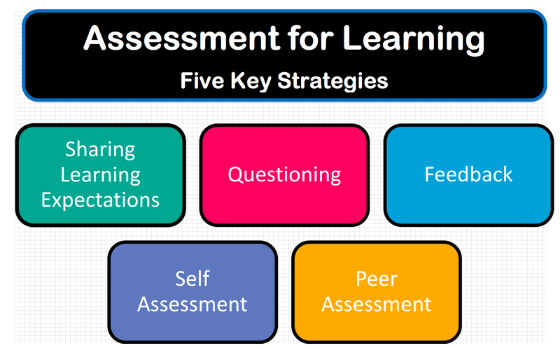

As children begin returning to school, finding out what they have learnt and what they haven’t is crucial to be able to start filling the gaps in knowledge and understanding.
For both children working and home and children working in school, getting and giving feedback is important. Feedback to children and their parents needs to be:
- Timely – just like in school, the sooner misconceptions are addressed the sooner they can be rectified
- Regular – we all respond better to carrying out tasks when someone is noticing what we are doing! Regular feedback makes children feel that they – and their work – is valued
- Meaningful – just like the feedback we provide in school, children need to know what they are doing well and what they can do to make their work even better
- Positive – self-esteem may be low, emotions may be high, resilience may have taken a dive…. Our interactions with children need to be positive, thoughtful and kind
- Manageable – teachers are working hard. Their work-life has changed beyond recognition and many are juggling other responsibilities and challenges in their home-life. Feedback needs to be all of the above for the sake of the children but needs to be manageable for teachers within everything else they are being expected to do at this time.

Quality feedback will enable teachers and school leaders to:

- work out what activities are working well at home and how you might need to adapt or change these
- look for patterns in learning where there are likely to be gaps and plan how and when to address these
- begin to plan for your recovery curriculum in September
What could feedback look like with remote learning?
1. Using email. Where possible, being available to students during lessons via email can provide one simple mechanism for providing feedback. It is particularly effective for providing responses to students’ questions.
2. Feedback could be provided using voice over technology, such as Showbie or SeeSaw. More information can be found here.
3. Use Loom for recorded whole class feedback, where appropriate (research shows 1:1 feedback is the most effective), and modelling. A brief guide to using Loom can be found here

Assessment should:
- not be about big baseline assessment tests – the gap analysis would be too complex
- instead involve low-stakes, formative assessment to identify gaps or misconceptions (for example, questioning or quizzes)

Questions teachers could consider as we move to a blended learning experience

Question | What Does This Look Like? | How do we know it is effective?
How can we help each student to feel that they have had some success in our subject over the last few weeks and to therefore keep them motivated? E.g simple quizzes | Regular 1:1 contact.  Focused feedback.  Setting simple quizzes as part of lessons to give a sense of achievement. | Teacher feedback to SLT shows consistent success felt by pupils over time.  Pupil feedback.  Parent feedback.
How can we ensure that we don’t panic our students? We want to reinforce the importance of their engagement with online lessons. We should however be realistic about how much work we are setting and reinforce the expectation that they stop at the end of the school day and aren’t given homework. | Set a clear timetable that has daily expectations shared well in advance.  Make sure daily exercise is part of the expectation.  Regular 1:1 contact should include a well-being check.  Parents understand school’s expectations and can understand that they can be flexible with the timetable to avoid overload. | Teachers will assess this through daily interactions at school and regular 1:1 contact with home.
How can we celebrate the engagement and work produced by students so far? How can we make students perceive that it is the norm to engage with the lessons and to complete the work, but not overwhelm them? | Share examples of good work on the website platform or in a newsletter.  Send videos from staff congratulating individual pupils for effort as well as achievement. | Pupil feedback shows a pride in work and an appreciation of the value placed upon learning/effort by the school.  Parental feedback.
How can we make the visit to school experience as normal as we can? | Post video walk rounds prior to return showing how things are different and also the same.  Ensure pupils are clear about expectations, systems, processes (where to go, what to bring etc). | Staff feedback.  Parent feedback.
How can we provide opportunities for students to interact with each other whilst socially distanced? This is what will have been lacking during lockdown. | Online (Zoom etc) meetings for those still at home – this can be for social purposes as well as academic. | Pupil feedback during group or 1:1 contact.
How can we try and check that each student is able to access the work, has a quiet place at home to work etc? | 1:1 contact.  Open up parts of school eg IT suite for vulnerable children to drop in – space and staff dependent. | 1:1 contact notes to feedback to SLT.
How can we share the big picture with our students in terms of what they have learned so far this year, what’s coming up in the next few weeks, and what they will be taught next year? | Alleviate anxiety by: avoiding negative language (gaps, catching up etc); give clarity about exams when available; inform parents by newsletter; use school website to inform especially when transferring between phases. | Look at information provided to pupils and parents and ensure clarity.  Reduced anxiety reported amongst children.  Enhanced communication between staff and schools to ensure strong transition.
What habits, routines, behaviours (old and new) will we need to establish, reinforce, remind? | Pupils are reminded about expectations in a planned and coherent manner once they return to the school setting.  Consider well-being – some schools report that pupils want to get on with their learning whilst others respond positively to PSHE and well-being sessions. Keep both under review and plan flexibly for the needs of your children. | Normality will resume!

Case Studies

EdTech

https://edtech-demonstrator.lgfl.net/support-and-resources/event-archive

Maths

The NCETM has produced some home learning case studies for Maths. https://www.ncetm.org.uk/resources/54431

School A

We put learning for the week on the class pages on our website and the website is used to keep in contact with pupils about their learning, several pupils contact teachers on a daily basis. Children are mainly using BBC bitesize so they have English and maths each day and 1 other subject. We add spellings/ phonics and other activities to boost this. Many children are doing mathletics and we congratulate them on the website for achieving certificates.
Now that most of the year 6 children are in school the children not attending have access to the learning being done in the class instead of Bitesize.

We keep in contact with all children weekly:
All class teachers phone or speak to the children and a family member via zoom weekly. We check everyone is well and coping with the situation as well as giving advice on learning and asking what other things they would like to support learning.
Teachers and SEN leaders phone vulnerable/SEN children weekly and if there is no reply to calls this is followed up -texts are sent etc
Family Link Partner keeps in contact with families checking their well being and delivering learning as needed. Also parenting classes are being led on line for families needing support with behaviour management during this difficult time.
Staff have recorded stories and these are put on the website
Children who can't print learning at home have had packs taken to their homes
Zoom meetings happen in most classes - children play maths games e.g. bingo, I'm thinking of a number... etc and have paper and pencils at the ready to join in!
At other times they ask to have a chat in smaller Zoom groups so some classes have arranged this. TAs join in some zooms too.
Many families are engaged in putting photos of children's activities on our Instagram page and staff add comments of encouragement to this regularly.

For children who have returned, we are doing daily PE sessions as some of the year 6 children had had very little exercise during the lockdown - some not having hardly been out and fitness levels were low.

Children who have returned have settled back to school and learning really smoothly and happily and we feel the regular contact has been crucial in this.

School B
We give feedback for any tasks handed in and, although it is time consuming, it really engages the children. They have enjoyed and been motivated by that two-way communication. It's a way we have used TA time and, at the moment, one of our shielded TAs gives a lot of the feedback.

School C

We use Google Classroom and by far the most useful thing for online teaching has been the Google extension Screencastify, https://www.screencastify.com/. It can be added to Google Chrome and can then be used to record your screen, either with you talking about your screen or with a small video of you in the corner as you talk about the screen. Having the voice and image of the teacher has certainly motivated our younger children more. The videos last for a maximum of 5 minutes so you have to think very clearly about the key messages you want to communicate.

School D

We deliver daily lessons for maths and English. These are short lessons – about 10 mins for KS1 and 20mins for KS2. We set work from these lessons so children can practise at home. We also set one other activity a day around topic work. We encourage the children to send us pictures of their wok so we can give them feedback. We also ring every child once a week to check on their wellbeing and all vulnerable children get extra calls from the TA or Senco.

School E

We use google classroom and encourage children to upload their work so we can give feedback. Some take a picture on a mobile phone and we call them. All children get at least a weekly phone call and our vulnerable learners more. We open school every day from 11-12 for anyone without a computer so they can safely access online learning.

Synopsis of Research:

Visible Learning Effect Sizes When Schools Are Closed: What Matters and What Does Not https://www.gloucestershire.gov.uk/schoolsnet/school-provision-during-covid-19-crisis/home-learning/

A summary of Dr John Hattie’s paper. He explores the current pandemic and links it to school closures at other times and lessons learnt (Hurricane Katrina, New Zealand earthquake). The full text can be found here:
https://corwin-connect.com/2020/04/visible-learning-effect-sizes-when-schools-are-closed-what-matters-and-what-does-not/

- Provide home learning activities that are optimised to learning – build on prior learning, add a bit of new learning – don’t just provide tasks to keep pupils busy;
- Chunk learning offering feedback in between;
- Deliver learning that parents find difficult – Maths, Science – but get parents to read, read, read with their children;
- Create opportunities for social interaction: between teacher and pupils and pupils and pupils – don’t be afraid to use pupils’ (appropriate) access to social media;
- Build in evaluation opportunities, offer regular individual feedback;
- Understand that learning online is different – there can be an overemphasis on content and repetition so teacher evaluation of a pupil’s learning is vital;
- Build on symbols, rituals, and identity; model connectedness; use stories and other artefacts so that when schools reopen there is a symbol, a thing, an event—a mosaic, a play, stories, collective memories of the at-home socially distancing experience. Schools, no matter via what medium, can be hubs of response and recovery, a place to support emotional recovery and promote social togetherness.

Summaries of DfE guidance published on 12 June 2020
Planning a curriculum to teach at school and at home
https://www.gov.uk/guidance/planning-a-curriculum-to-teach-at-school-and-at-home?utm_source=d22f8df5-e496-4ab3-834b-e4a47ffaa68c&utm_medium=email&utm_campaign=govuk-notifications&utm_content=daily
Case studies include:
- Deciding what to teach on site and what to teach remotely: focus on reading at home and focus on R,W,M basics upon return
- Deciding contact time by subject: subjects that need to be taught (Maths, Science) will be prioritised upon return
- Teaching the curriculum with less time on site: identify core concepts in subjects that children must master
- Maintaining curriculum breadth with less classroom time: deliver basics but also “electives” so pupils can decide aspects of the wider curriculum to access from home. Hold writing competitions or art exhibitions

Pastoral care in the curriculum
https://www.gov.uk/guidance/pastoral-care-in-the-curriculum?utm_source=8c2a0a8b-1930-4280-9286-4dba8ac86fca&utm_medium=email&utm_campaign=govuk-notifications&utm_content=daily
Case studies mention:
- Communicating regularly with parents so that information has been gathered for individual children prior to return
- 1:1 tutor meetings (in secondary schools)
- Recording lessons held in school for those at home to access
- Live online tutorials to enable questioning, address misconceptions etc – scaffolding these for SEND pupils

Identifying and addressing gaps in pupils’ understanding
https://www.gov.uk/guidance/identifying-and-addressing-gaps-in-pupils-understanding?utm_source=6fa34385-50a7-4d20-af56-539b6e4fa441&utm_medium=email&utm_campaign=govuk-notifications&utm_content=daily
Case studies mention:
- Low stakes quizzes to identify gaps in learning both online and upon return
- Individual online feedback is more effective than whole class online feedback

Supporting staff in curriculum planning for a phased return
https://www.gov.uk/guidance/supporting-staff-in-curriculum-planning-for-a-phased-return?utm_source=d436e534-9075-4b05-b00e-6f7e1ad00477&utm_medium=email&utm_campaign=govuk-notifications&utm_content=daily
Case studies mention:
- Aligning home learning with in-school learning
- “Now” and “Next” teams to share the planning load and enable pupils to seamlessly work at school and at home
- Well- structured curriculum booklets that pupils can work in both at school and home – (not clear but assume the booklet is online?)
- Balancing the ideal with the realistic by identifying crucial concepts for teaching
- Delivering challenging concepts in class, filming and making available online
- Prioritising reading activities at home that are accessible
- Avoid a reactive (planned without thought) or an activity curriculum (planned around the activity rather than the desired learning)

Case studies: remote education practice for schools during coronavirus (COVID-19)
https://www.gov.uk/government/collections/case-studies-remote-education-practice-for-schools-during-coronavirus-covid-19?utm_source=963b42f1-4e33-4e20-92d7-86ac0585ee1d&utm_medium=email&utm_campaign=govuk-notifications&utm_content=daily
This document draws together case studies first issued on 5 May and 21 May alongside two new case studies published on 12 June. Points arising from these studies are covered elsewhere in this document.

Examples of teaching practice during coronavirus (COVID-19)
https://www.gov.uk/guidance/remote-education-practice-for-schools-during-coronavirus-covid-19?utm_source=6be71a0e-17f3-425a-9515-25a05c3895fe&utm_medium=email&utm_campaign=govuk-notifications&utm_content=daily
This document collects together the above documents published over time.

8. Maths and English curriculum support – reopening of schools – curriculum support for September 2020
Timeline | Maths | Reading | Writing
Monday 13th July | Live teams meeting with breakout rooms.  Asynchronous tasks set for discussion during session  Agenda:  Generic for maths and English subject leaders  - Generic welcome and well done for all their work in schools  - Highlight relevant points from DFE guidance document  - Share how we will support schools with prioritised curriculum  - Sharing of blended learning document.  - Planning for second potential closure  Breakout to subject specific rooms  - Share materials available to support prioritised curriculum  - Discuss strategies for assessment  - Q & A session
Wednesday 15th July | Headteacher Update  English Updates  Maths updates  To include what has been offered to subject leaders already and offer additional session if they have not attended. Head teachers invited to additional session.
Wednesday 15th July | Live Teams presentation and discussion offered to all Y7 teachers:  English and maths  - Likely topics children will have missed out on  - Prioritised curriculum  - Resources to support this  - Q & A and any further support they might need (to encourage further engagement)
Monday 20th July | Repeat of session on 13th July:  Agenda:  Generic for maths and English subject leaders/Headteachers  - Generic welcome and well done for all their work in schools  - Highlight relevant points from DFE guidance document  - Share how we will support schools with prioritised curriculum  - Sharing of blended learning document.  - Planning for second potential closure  Breakout to subject specific rooms  - Share materials available to support prioritised curriculum  - Discuss strategies for assessment  - Q & A session
End of summer term | Schools equipped with resources to support maths curriculum | Advise given to schools in line with DFE guidelines to encourage children back to reading | Schools equipped with resources to support writing curriculum
August 20th |  | Materials available to support prioritised reading curriculum
August 21st | Short webinar available for schools to use during TD on using new prioritised curriculum and assessment resources for maths | Short webinar available for schools to use during TD on using new prioritised curriculum and assessment resources for writing | Short webinar available for schools to use during TD on using new prioritised curriculum and assessment resources for writing

