Dear Chameleon parents and carers,

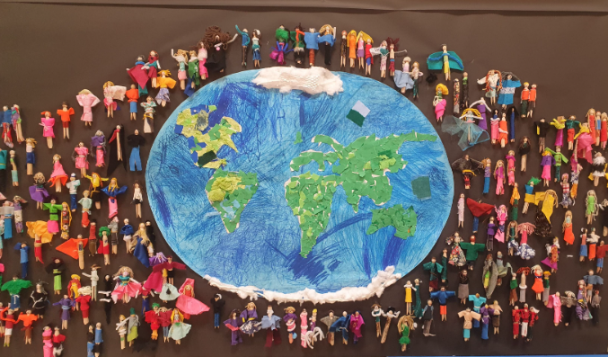
We had an excellent start to the academic year - the children all seem very settled into their new year groups and into life in Chameleon class, rising to our high expectations towards their learning behaviours and attitudes. We are very proud of them!

The first term has been busy as always. It was so lovely to see the children working together across the school with their families to make their ‘peg people’ which are now on display in the hall.

Our topic this term has been focused on World War II. There was huge enthusiasm from the children towards this topic, with excellent work produced. The children wrote newspapers about the blitz, flashback stories based on ‘The Piano’ and enjoyed dressing up on our trip to STEAM where they were ‘evacuated’ and put lots of their learning into context. We had some brilliant feedback from the staff at STEAM about the children’s behaviour and knowledge – well done, Chameleon class! Thank you for arranging such brilliant costumes and lunches which really helped to bring the day to life.
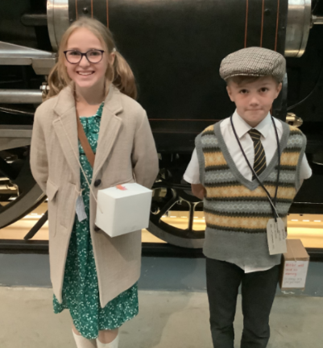
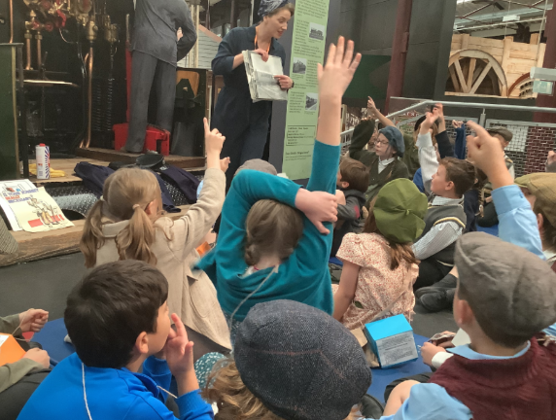
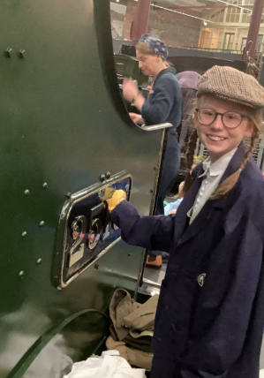
Many of the Year 6 children have enjoyed taking part in Bike-Ability where they learned to ride their bikes safely on the road, and I know there are lots of enthusiastic Year 5s waiting for next year! We have also started buddy reading for the Year 6s who have made a fantastic start, being super role models to the younger children and showing our value of friendship.

Next tern, our topic focus is ‘Location, Location, Location’, where the children will learn about trade in geography and do some exciting writing about explorers and interesting places around the world.

P.E days will change to Tuesday and Friday next term, with no need to bring shin pads any more except for the first week. Thank you as always for your support, and we will see you after half term.

Mrs Webster, Mrs A Flynn, Mrs R Flynn
The Chameleon Team

