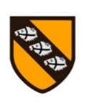

Pegasus Class

**Superheroes in History**

**Y1/2, Autumn 2**

**2022/23**

**This is an overview of some of the subject matter that we will be learning about this term.**

**Science – Everyday materials:**

Explore different types of material and distinguish between the object and the material it is made of, describe properties, compare and group different mayterials.

Y2: properties of different materials

Both year groups will practise working scientifically by asking questions and suggesting answers, making observations, sometimes over a period of time, performing tests, identifying and classifying as well as gathering and recording data.

**English:**

This term children will continue to develop their writing skills by learning about inspirational people in history, such as Guy Fawkes, Rosa Parks and Emily Davison and write recounts about their lives. Learning about fire safety and making edible sparklers will provide opportunity for writing instruction texts. Bonfire Night will be perfect for some more poetry!

Remembrance Day and Anti-Bullying week will provide further writing opportunities.

Children will learn about the Christmas story and by rehearsing our Nativity Play, will be learning about playscripts.

**Computing:**

MR P DARES projects

Programming – ‘My Robot Helper’ Scratch Jr project.

**Maths:**

**Y1**: Continue to practice numberbonds to 10, addition and subtractions calculations also involving word problems.

**Y2:** Continue to practice different methods and strategies for adding and subtracting 2 digit numbers. Multiplication of 2, 5 and 10.

**This term’s value:**

Respect

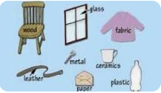

**Field and Forest:**

This term we will begin our Field and Forest learning which will encompass many areas of the foundation subject curriculum. We will be developing social and emotional skills, building confidence and team work.

**RE: Understanding Christianity**

Unit 1.3 – Incarnation

Why does Christmas matter to Christians?

**RHE:**

SCARF – Valuing Difference

**Art:**

We will develop our drawing skills by drawing portraits of our ‘Superheroes in History’ and use decorative techniques when making Christmas cards and craft activities. Y1 will focus on creating darker and lighter tones in painting by using black and white, whilst Y2 will explore this without the use of black and white.

**DT:** making of edible sparklers and Christmas biscuits

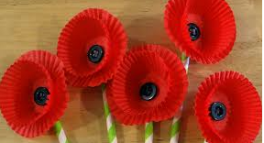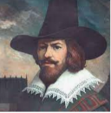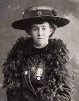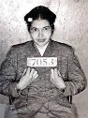

**Music/Singing:**

This term we will be rehearsing for our Christmas Nativtiy- dates to follow. This will involve singing, as we learn the songs and using percussion instruments to add effects.

**Humanities - History:**

We will learn about Superheroes in history, Guy Fawkes, Rosa Parks and Emily Davison

**PE:**

Gynmatics- stretching, curling and arching along with Yoga.