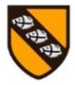
Pegasus Class – End of term 1, 2022, Newsletter
Pegasus Class has had a great start to the new school year!
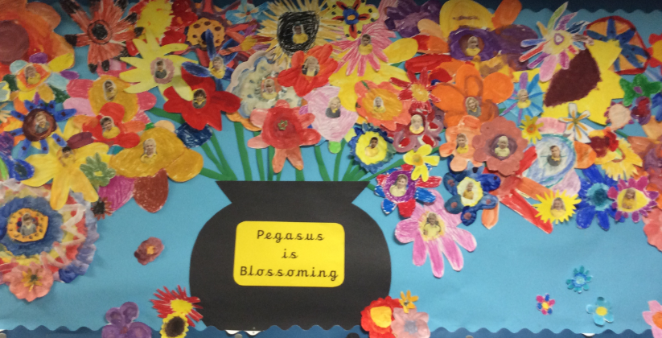
The children arrived to a changed classroom with fewer chairs and tables providing more space for learning opportunities. Children have familiarised themselves with classroom rules and routines and are becoming increasingly settled in this framework and beginning to blossom!

Using information texts about castles we learned the correct names for different parts of a castle. Our narrative writing focused on stories about knights, dragons and castles and the children have worked hard to apply their learned writing skills. Other skills were practiced when creating dragons and castles in a variety of ways.
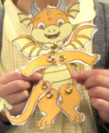
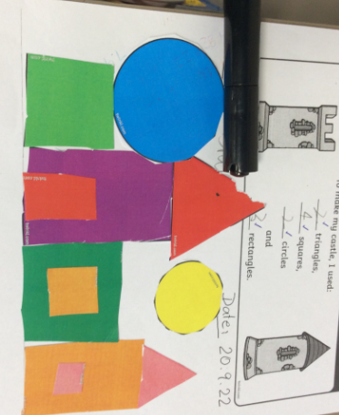
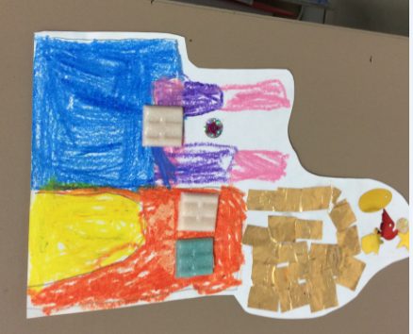
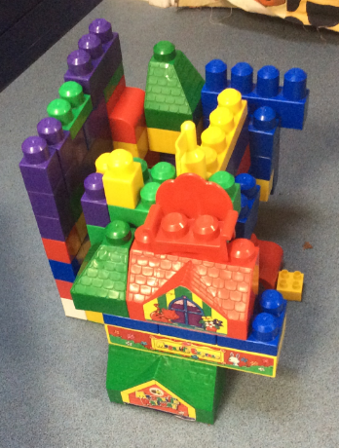

Together with the whole school we celebrated our Harvest Festival at St Peter’s Church and Pegasus Class shared their ‘Tasty Food song’.
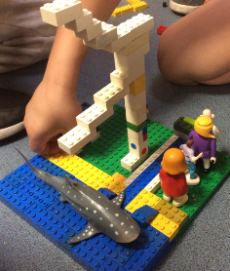
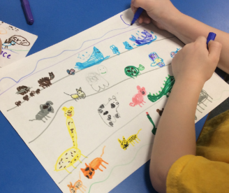
In RE the children have learned about the creation and are encouraged to ask questions such as ‘I wonder why the sea is blue?’ whilst expressing their learning in different ways, such as poetry, art or construction materials.
In science we have explored some everyday materials; this will continue during the next term in order to consolidate our learning.
All children continue to work hard in Maths and are now competent to independently sign in (and out!) to their Numbots accounts.
In history the children investigated aspects of the life of Queen Victoria, using ipads for their research. This linked very well to their work on e-safety which, as a school, we revisit regularly.
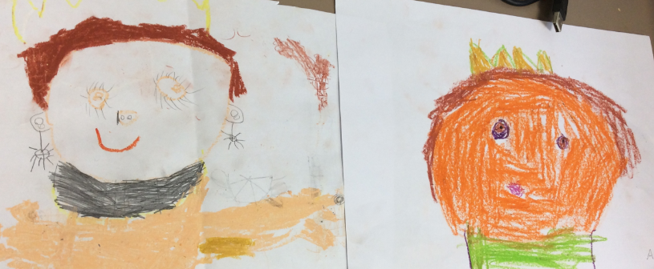
It’s been a busy term and we hope that you and your children will have a lovely break and come back refreshed and full of energy for term 2.
Thank you so much for all your support during this term,
From all of the Pegasus Teaching Team

