

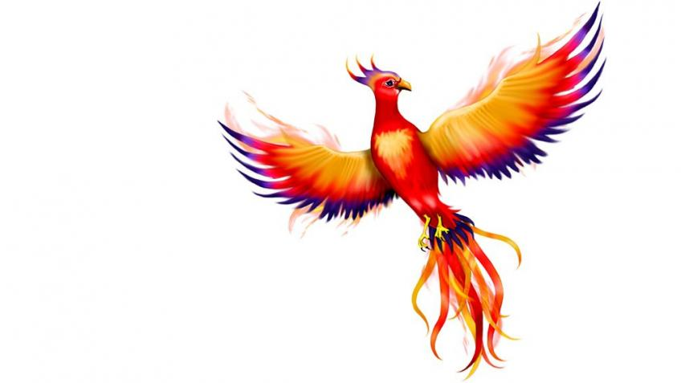

Phoenix Class

**This is an overview of some of the subject matter that we will be learning about this term.**

**Science:**

* I can identify common appliances that run on electricity.
* I can construct a simple electrical circuit.
* I can identify a fault in a circuit.
* I can recognise some common conductors and insulators.
* I can recognise that a switch opens and closes a circuit.
* I can use scientific evidence to answer questions or support my findings.

**Computing:**

* MR P DARES unit- Podcasting
* iPad apps: Pages and Keynote
* Research information and arrange as a teleprompter
* Combine audio with mixed-media slides

**Maths:**

Y3

* 3, 4 and 8 times tables
* Multiplying 2-digit numbers
* Dividing 2-digit numbers

Y4

* 6, 7 and 9 times tables
* Multiplying 3-digit numbers
* Dividing 3-digit numbers

**English:**

* Sounds Write phonics and spelling programme
* Word classes – and how to use effectively
* Direct and reported speech
* Playscripts
* Diaries
* Adverts



Autumn

Term 2

**RE:**

* How do believers care for others and the world?
* Studying and comparing creation stories – Christian, Muslim, Hindu
* 21st century creation stories
* How can we show care? How do charities help people

**Music/Singing:**

* Charanga theme – What Stories About The Past Does Music Tell Us?
* Singing, glockenspiel playing, improvisation and composition, listening skills, elements of music, emotive music

**Art/DT:**

* Indian Folk Art
* [Madhubani](https://buzzingbubs.com/articles/madhubani-indian-folk-art-activity-worksheets-for-kids), [Warli](https://buzzingbubs.com/articles/warli-indian-folk-art-activity-worksheets-for-kids), Gond and Mandala
* African folk art – batik artwork
* Folk art’s connection with stories

**PE:**

* Yoga – performing different poses, holding shapes with control and balance, bending and stretching, controlling breathing
* Rounders – I can develop basic batting and throwing skills and communicate with my team.

**Humanities:**

* Trade and Transport
* UK Trade links – Important Imports and Exports
* Fair Trade
* Global supply chains
* Types of transport

**PSHE:**

* Value for Term 2 – Respect
* Scarf PSHE theme – Valuing (and celebrating) Difference
* Looking at families, friends and wider communities