

Pegasus Class

**The Big Freeze**

**Y1/2, Spring 1,**

**2022/23**

**This is an overview of some of the subject matter that we will be learning about this term.**

**Science – Animals including humans**

The children will learn to dentify and name a variety of common animals including fish, amphibians, reptiles, birds and mammals, as well as a variety of common animals that are carnivores, herbivores and omnivores.

They will describe and compare the structure of a variety of common animals including fish, amphibians, reptiles, birds and mammals and identify and name, basic needs of animals including humans for survival.

**English:**

This term children will continue to develop their writing skills by exploring stories with a ‘freezing theme’. The stories we will use will be Big Bear, Little Brother by Carl Norac and Kristin Oftedal and an Inuit tale called The Polar Bear Son. These stories, as well as our geography work, will provide us with some information about Arctic and Antarctic animals. We will deepen this knowledge by gathering more information and using the genre of information texts, we will share our information.

**Maths:**

**Y1**: SAddition and subtraction within 20, Length and height, Numbers to 40, Shapes and Patterns

**Y2:**. Addition with renaming, Multiplication, Division, Length and Mass, Temperature, Picturegraph

**Computing:**

MR P DARES projects

Photography – simple photoshopping





**This term’s value:**

Truthfulness

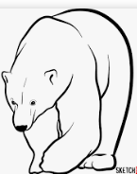

**Field and Forest:**

This term we will be building hog houses and other winter homes for animals, spot different types of twigs and go on a winter scavenger hunt. All these activities will encourage children’s social, emotional and team building skills.

**RE: Leaders and Teachers**

Who is an inspiring person and who inspires you? Example of Jesus in Christisn Faith as well as Moses in Judaism.

**RHE:**

SCARF – Keeping Safe

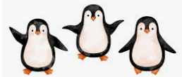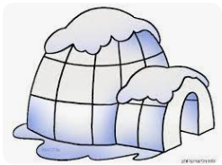

**Humanities – Geography:**

The 5 oceans, their location and what is special about them. Who lives in these oceans?

**Art:**

We will explore warm and cold colours and then use our knowledge to paint a winter landscape in the style of Caspar David Friedrich.

**DT:**

Igloo challenge using marshmallows

Extension: create a snowmobile using scrap material

**PE:**

We will follow PE Passport and explore Animal Dances.

**Music/Singing:**

We will use Charanga Music scheme and focus on Journeys-Ship on the ocean.