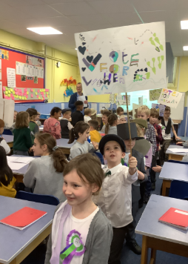
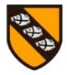
Pegasus Class – End of term 2 Newsletter
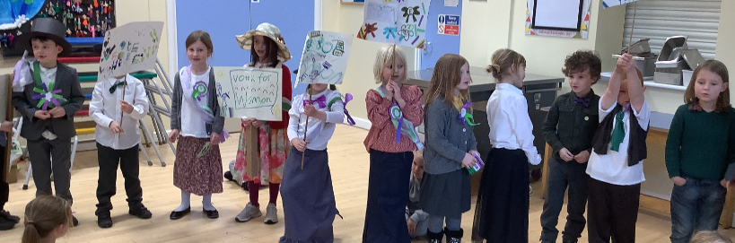
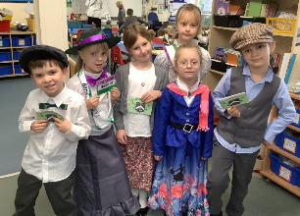
We had a great start into term 2 being all sparkly and ‘whooshy’ by learning about Guy Fawkes and the Gunpowder Plot! This was followed by looking at potentially lesser known heroes in history, such as Rosa Parks, Emmeline Pankhurst and Emily Davison. We were so impressed by how the children took to this topic; making protest placards, learning a Suffragette Song, creating badges and sashes. We walked around the school and shared our protest with the other classes. Some complained to their teacher that they had never done this. Some children shared their independently prepare speeches. We did a poll and I am pleased to say that nearly all children felt, women should be allowed to vote!
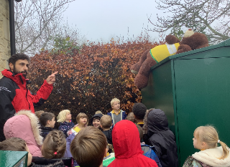
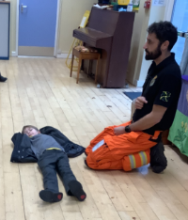
We celebrated Remembrance Day and Anti-Bullying week, clarifying for children what bullying actually means.
We also had a visit by the Wiltshire Air Ambulance to learn about their fantastic work.
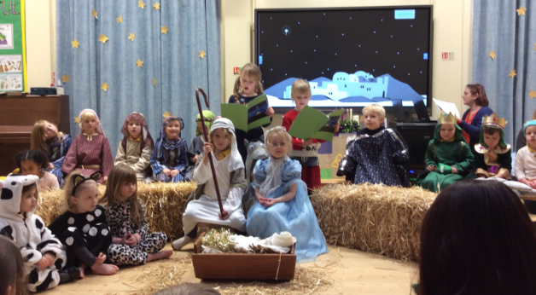
Before long it was time to get started on our Nativity Production, and we are sure you agree with us that the classes did a wonderful job. They sang in unison, remembered their lines and where to move to, as well as sharing their beautiful costumes you had provided.
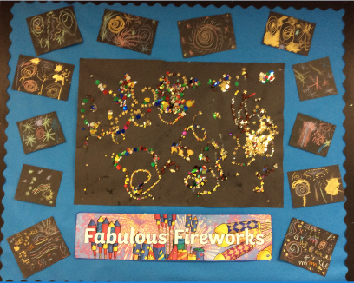
In Art we created various fireworks using a variety of media. We also drew portraits of the Superheroes we had learned about and the children used a variety of shading activities to improve their work.
All children are becoming increasingly competent at our phonics scheme. Please continue to read with them at least 4 times, even if the children are fluent. That’s the idea.
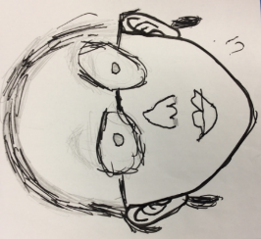
We have continued to do activities to help children with their social/emotional well-being, either by following the SCARF programme but also with additional, discreet sessions.
Wishing you all a Merry Christmas and a lovely break,
From all of the Pegasus Teaching Team

