

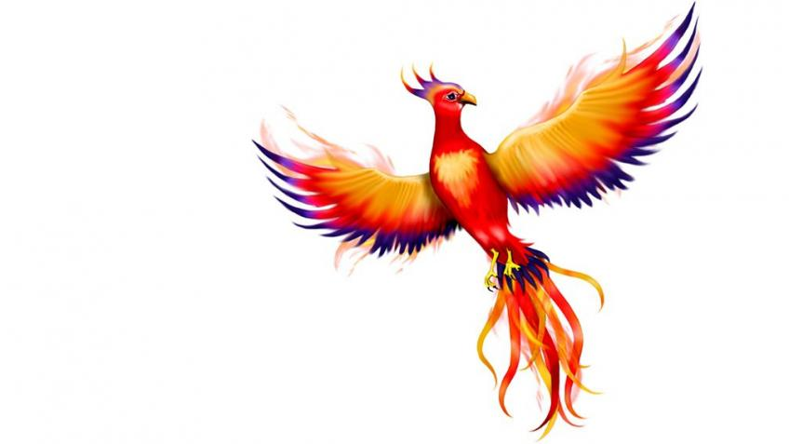

Phoenix Class

**This is an overview of some of the subject matter that we will be learning about this term.**

**Science:**

* I can describe and explain sound sources.
* I can explain how sounds travel
* I can explore ways to change the pitch of a sound.
* I can investigate ways to absorb sounds.
* I can make a musical instrument to play different sounds
* I can evaluate my learning.

**Computing:**

* MR P DARES unit- Data handling
* Google Forms – devising questionnaires, analysing responses, creating suit able data charts, presenting findings

**Maths:**

Y3

* Multiplying and dividing larger numbers
* Length, mass and volume

Y4

* Multiplying 3-digit numbers
* Dividing 3-digit numbers
* Graphs, fractions, time

**English:**

* Sounds Write phonics and spelling programme
* Developing effective description
* Creating tension in narrative
* Newspaper reports
* Poetry techniques
* Experimenting with sentence structures

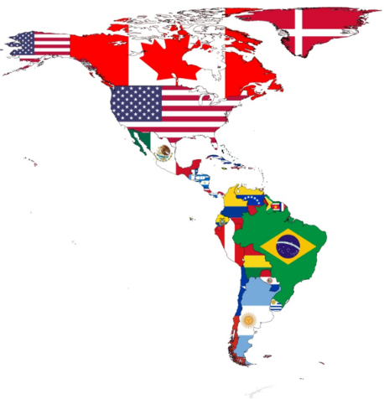 I can

Spring

Term 3

**RE:**

* What are the deeper meanings of festivals?
* What is worth celebrating?
* Significant stories and key events associated with festivals
* Children’s own experiences and views on celebrations and how they affect actions

**Music/Singing:**

* Charanga theme – How Does Music Make the World a Better Place?
* Singing, glockenspiel playing, improvisation and composition, listening skills, elements of music, musical genres

**Art/DT:**

* Pop Art – focus on Andy Warhol
* Recreate Pop Art styles using different media – paints, collage and pencils
* Compare types of Pop Art

**PE:**

* Swimming at the Olympiad Sports Centre – initial assessments, basic and advanced swimming strokes
* Gymnastics – I can create asymmetrical and symmetrical balances and take weight on my back, shoulders and bottom in motion.

**Humanities:**

* The Americas
* Countries and capital cities
* Grid references
* Biomes of the Americas
* Human and Physical features
* Field work study

**PSHE:**

* Value for Term 3 – Truthfulness
* Scarf PSHE theme – Rights and Responsibilities
* Volunteering, stereotypes, staying safe, working together