

Pegasus Class

**Out and about**

**Y1/2, Spring 2,**

**2022/23**

**This is an overview of some of the subject matter that we will be learning about this term.**

**Science – Everyday materials**

We will revisit Everyday materials – identifying different materials and describing them and their suitability for different purposes, investigate material for their suitability as an umbrella.

**Maths:**

**Y1**: Additions and Subtractions up to 40 and word problems, shapes and patterns, height and length, intro to multiplication

**Y2:** 2, 5 and 10 times tablke nd wordproblems, length, mass, temperature and pictograms

**English:**

This term will start of with a strong link to geography. We will use the book ‘A walk in London’ by Salvatore Rubbino to inspire us to explore our own surroundings and write a recount about it. Collecting information to create an information text will eventually lead towards creating a guidebook for a visitor.

For our narrative writing we will use ‘A house that once was’ by Julia Fogliano and Jane Smith.

**Computing:**

MR P DARES projects

Presentation – interactive photo images using the app Chatterpix





**This term’s value:**

Perseverance

**RE: Salvation**

Why does Easter matter to Christians?

**RHE:**

SCARF – Rights and Responsibilities

**Music/Singing:**

We will use Charanga Music scheme and travel to the Animal Faitr.

**Humanities – Geography:**

We’ll hope the weather will be fair so we can explore our local surroundings and learn about and apply basic map reading skills.

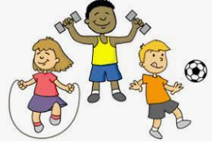

**Field and Forest:**

We will look for suitable materials in nature for creating an art piece in the style of Andy Goldsworthy. We will build Easter nests and Easter gardens and enjoy the awe and wonder of new life in spring.

**Art:**

We will explore the artist Andy Goldsworthy and his creations and create our own art work using natural materials. This will also provide a link to Field and Forest activities.

**DT:**

Make Hot Cross Buns

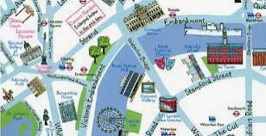

**PE:**

We will follow PE Passport and explore Fundamental Movement skills such as agility, balance and coordination whilst sharing space considerately and travelling backwards .