

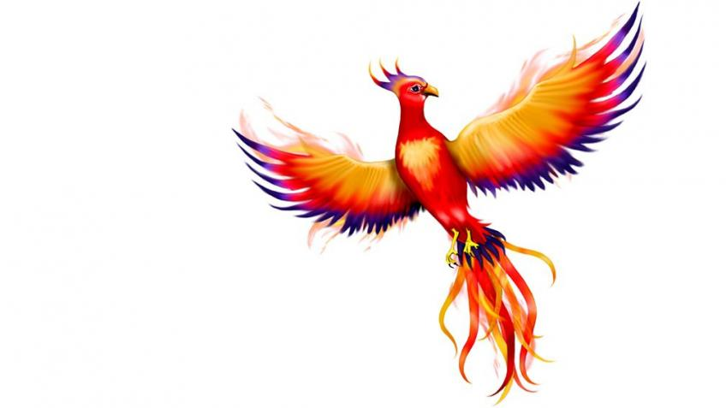

Phoenix Class

**This is an overview of some of the subject matter that we will be learning about this term.**

**Science:**

* Compare different kinds of rock based on their appearance.
* Making observations by examining different types of rock.
* Describe in simple terms how fossils are formed.
* Understanding Mary Anning’s contribution to palaeontology.
* Recognise that soils are made from rocks and organic matter.

**Computing:**

* MR P DARES unit- Line drawing animations. Keynote app
* Link with class story to create ‘extra’ scene with animated line drawings and text
* Use of sound for atmosphere

**Maths:**

Y3

* Mass, volume and Time
* Money
* Graphs and charts

Y4

* Graphs, fractions, time
* Decimal numbers
* Money

**English:**

* Sounds Write phonics and spelling programme
* Non-chronological reports – fantasy creatures
* Letter writing
* Formal and informal writing styles
* Persuasion – constructing arguments for and against

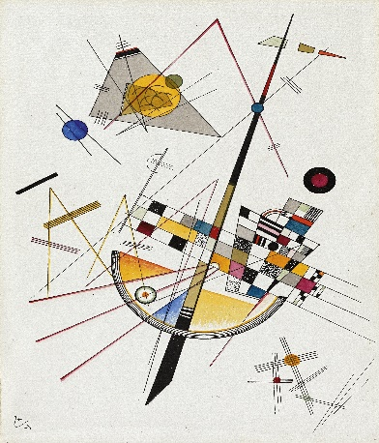 I can

Spring

Term 4

**RE:**

* Understanding Christianity: Why do Christians call the day Jesus died ‘Good Friday’?
* Events of the Easter story
* What did Jesus’ mother think and feel about the events of Holy Week?
* First-person diary writing

**Music/Singing:**

* Charanga theme – How Does Music Help Us Get to Know Our Community?
* Singing, glockenspiel playing, improvisation and composition, listening skills, elements of music, musical genres

**Art/DT:**

* Abstract Art – Focus on Kandinski
* Specific works study
* Line, colour and form
* How music can influence art
* Own abstract art – choice of media

**PE:**

* Swimming at the Olympiad Sports Centre – initial assessments, basic and advanced swimming strokes
* Gymnastics – Taking weight on back, bottom and shoulders in balance and in motion.

**Humanities:**

* The Americas - continued
* Human and Physical features
* The Amazon rainforest
* Atacama desert
* The Andes
* Compare and contrast

**PSHE:**

* Value for Term 4 – Forgiveness
* PSHE theme – Being My Best
* Things that keep me healthy
* Things that will help the environment