Langley Fitzurse Worship Council – 12th January 2023
Pupils: Alex (Y4), Emilia (Y3), River (Y4), Adonis (Y5), Summer (Y6), Elin (Y5),
Willow M (Y6), Zane (Y3)

Mrs Bloomer (Church Link), Mrs Winterburn (Executive Head)

Minutes from 18th November 2022
Mrs Bloomer apologised that she had not sent these out – they are added to the end of these minutes.

Actions

- New Collective Worship board is due to go up shortly
- Mrs Webster
- Outdoor Reflection Area – Mrs Tayler is going to come and paint the cross and look after the plants once the weather improves. Mrs Winterburn, along with pupils is going to approach the company about the bench. It was noted that leaves and rubbish need clearing, and the willow screens need attention.

Truthfulness Collective Worship
Members shared their thoughts and feedback from class discussions. Mrs Bloomer is due to lead CW next week and will send a script to school so member can take part. (done 16/1/23)
Values Tree
Pupils have helped make the trunk and branches of the tree. This will go in the hall, and over time leaves will be added linked with the school values, and pupils observations on who are living out the values and how. Mrs Winterburn asked the team to choose the colours for each value. After a lot of excellent discussion, listening and debate the following were chosen:
Friendship – Langley yellow. Bright, Buddies, our community
Respect – Red. Poppies
Truthfulness – Pale Blue. Clear skies, no clouds – the opposite of dark lies.
Forgiveness – Leaf Green. Fresh start, turning over a new leaf. Forgiveness allows both sides to grow.
Perseverance – Orange. Strong, determined.
Service – Gold. Celebration. Shining as a light.
ACTION: Pupils to write an explanation for why each colour was chosen and share with Mrs Winterburn to add to the display.
Christingle – 3rd February
In the afternoon of 2nd Feb, volunteers from church will come and help pupils make Christingles. Worship Council will plan and lead the service on the Friday morning. We shared ideas for music, prayers, theme and possibility of making Christingle marmalade if people didn’t use their oranges at home. Alex said he planted his whole. Summer said she planted the seeds. Many eat their oranges.
ACTION: Mrs Bloomer will send an outline to Mr Osler so music can be practised, and to pupils so they can write prayers (done)
Next Meeting: Wednesday 8th March, 1pm
The main focus will be on creating an Easter trail for Hercules class to enjoy.

Langley Fitzurse Worship Council – 18th November 2022
Pupils: Alex (Y4), Emilia (Y3), River (Y4), Adonis (Y5), Summer (Y6), Elin (Y5),
Willow M (Y6), Zane (Y3)

Mrs Bloomer (Church Link)

Minutes from 5th October

Actions

- New Collective Worship board is being replaced.
- Thoughts on Collective Worship – Mrs Winterburn was asked to share these with the staff team.

Courageous Advocacy – How can we make a difference?

Step 1 – Which charities do we already support during the school year – and why?

Pupils had created a list and we went through deciding how this fitted with the school vision, values and Bible verse.

Vision: We are an inclusive, friendly church school with a family feel. Our purpose is to Amaze, Excite and Inspire confident, happy and resilient children within our community, where everyone can reach their full potential.

Motto: Amaze, Excite, Inspire

Bible verse: Let us help each other to love others and do good (Hebrews 10: 24)

Values: Friendship, respect, Truthfulness, Forgiveness, Perseverance, Service

Key Bible Story: The Good Samaritan (The Kind Stranger) – Luke 10: 25 – 37

Charities we support:

- Poppy Appeal /Royal British Legion – respect and service
- Children in Need – friendship, service, perseverance
- Comic relief – friendship, service, perseverance
- Doorway – service, friendship, respect
- WaterAid
- Save the Children
- Bristol Children’s hospital
- Salvation Army
- The Children’s Society

Pupils also champion causes that are special and meaningful to them, e.g. fundraising for WWF. These might be local, national or global. The following steps might be used to move from supporting charities financially to making a difference (social action)
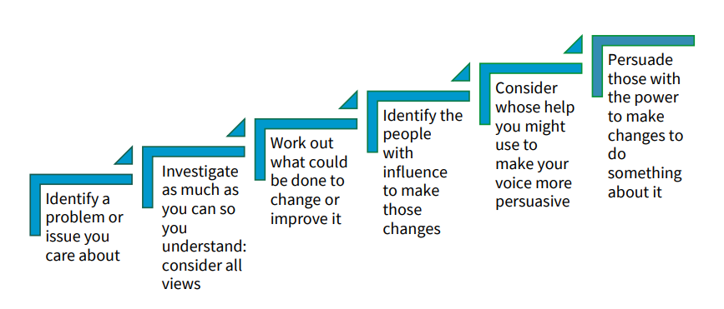
Different levels of advocacy:

- Awareness raising – using the village magazine, local press, etc
- Community influencing – presenting a case for issues you care about and appealing for action locally.
- Lifestyle changes – waste food, single use plastic, recycling pens.
- Consumer power – how and where might the school spend its money (ethical, environmental…)
- Engaging with decision makers – e.g. writing to local or national politicians

Chameleon class are currently focusing on Bin twinning – how might this be extended to a wider audience.

ACTION: Mrs Bloomer to speak with Mrs Webster about progression

Leading Collective Worship in T3
The value will be Truthfulness – members were asked to come to the next meeting with their ideas for prayers, story, songs, etc so we can plan together.

ACTION: Everyone to bring ideas to the next meeting

Feedback on Mission Area Youth Team Visit
Jessy and Tracy had been in to lead worship – Daniel and the Lions Den. Pupils gave feedback, which Mrs Bloomer will pass on.

Other items

Pupils raised issues about the Gazebo and climbing trail. This falls outside the Worship Council remit.

ACTION: Pupils to raise with the School Council

Priorities for the year ahead

- Outdoor reflection area – keep developing this. Mrs Bloomer to get in touch with Amy about plant care and painting the cross. School to think about artwork/symbols to decorate the area – but not too busy! Mrs Winterburn to work with pupils to commission a bench.

ACTION: Mrs Winterburn and pupils to source a bench.

- Create an Easter Trail for Early years/ KS1 (early T4)

- Church Trail – to link with NWMA Pilgrim Trail (competition to create a stamp for St Peter’s) For T5/6

- Developing opportunities for spiritual development

Date of Next Meeting in Term 4: TBC

