Langley Fitzurse Reading Spine
EYFS
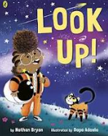 | 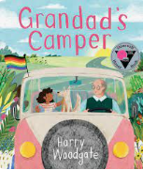 | 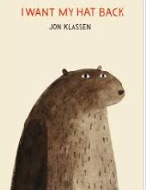 | 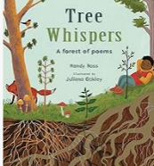 | 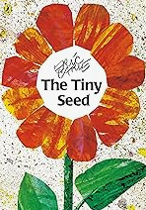  PS  HE | 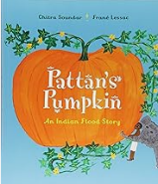 | 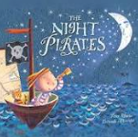 | 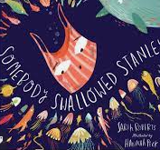  PS  HE | 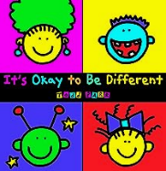 | 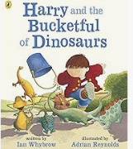 | 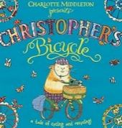 | 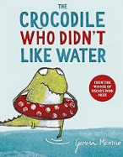
Look Up  by Nathan Bryon | Grandpa’s Camper Van  by Harry Woodgate | I Want My Hat Back  by Jon Klassen | Tree Whispers by Mandy Ross and Juliana Oakley | The Tiny Seed by Eric Carle | Pattan’s Pumpkin  by Chitra Soundar | The Night Pirates  by Peter Harris | Somebody Swallowed Stanley  by Sarah Roberts | It’s Ok To Be Different  PS  HE  by Todd Parr | Harry and the Dinosaurs  by Ian Whybrow | Christopher’s Bicycle  by Charlotte Middleton | The Crocodile who didn’t like water  by Gemma Merino
0020 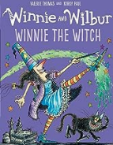 | 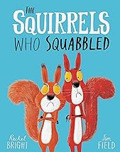 | 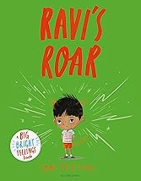  PS  HE | 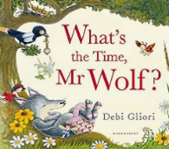 | 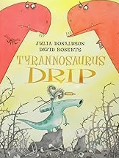  PS  HE | 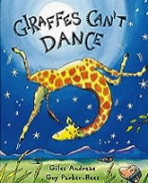 | 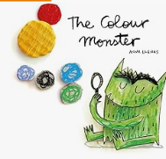  PS  HE | 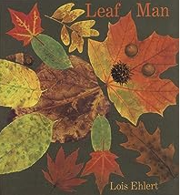 | 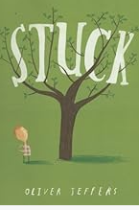  PS  HE | 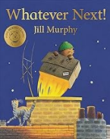 | 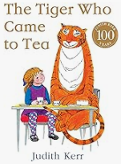 | 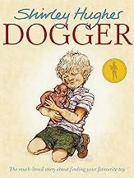
Winnie the witch  by Valerie Thomas | The Squirrels Who Squabbeled  PS  HE  by Rachel Bright | Ravi’s Roar  by Tom Percival | What’s The Time Mr Wolf  by Debi Gliori | Tyrannosaurus Drip  by Julia Donaldson | Giraffes Can’t Dance  PS  HE  PS  HE  by Giles Andreae | The Colour Monster  by Anna Llenas | Leaf Man  by Lois Ehlert | Stuck  by Oliver Jeffers | Whatever Next  by Jill Murphy | The Tiger Who Came To Tea  by Judith Kerr | Dogger  PS  HE  by Shirley Hughes
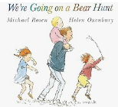 | 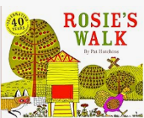 | 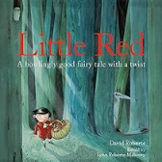 | 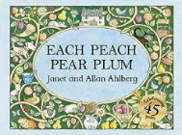 | 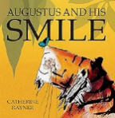 | 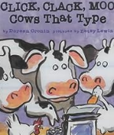 | 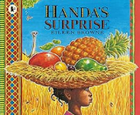 | 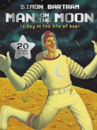  PS  HE | 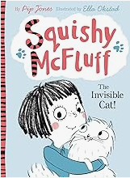 | 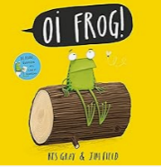 | 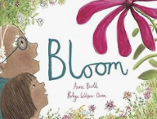  PS  HE  PS  HE | 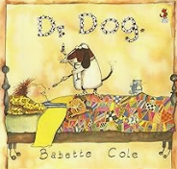
We Are Going On A Bear Hunt  by Michael Rosen | Rosie’s Walk  by Pat Hutchins | Little Red  by Lynn Roberts | Each peach, pear plum  by Allan and Janet Ahlberg | Augustus and his smile  by Catherine Rayner | Click clack moo  by Dorin Cronin | Handa’s surprise  by Eileen Browne | Man On The Moon  by Simon Bartram | Squishy McFluff  by Pip Jones | Oi Frog  By Kes Grey | Bloom: Hope In A Scary World  PS  HE  by Anne Booth | Dr Dog  by Babette Cole
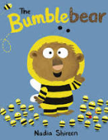 | 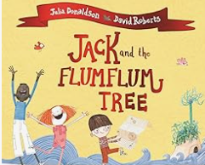
The Bumble Bear  by Nadia Shireen | Jack and the Flumflum Tree  by Julia Donadson
PS
HE

KS1
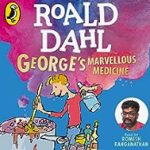 | 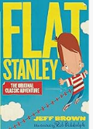 | 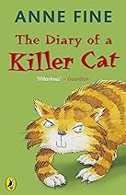 | 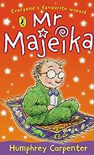 | 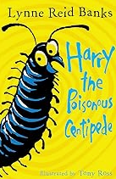 | 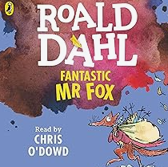 | 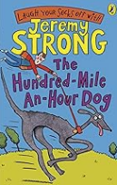 | 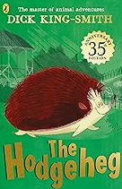  PS  HE | 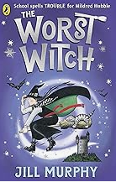 | 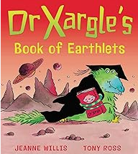 | 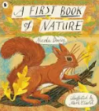 | 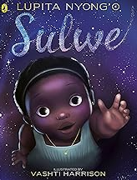
George’s Marvellous Medicine  by Roald Dahl | Flat Stanley  by Jeff Brown | The Diary of a Kiler Cat  by Anne Fine | Mr Majeika  by Humphrey Carpenter | Harry the Poisonious Centipede  by Lynne Reid | Fantastic Mr Fox  by Roald Dahl | The hundred mile an hour dog  by Jeremy Strong | The Hodgeheg  by Dick King-Smith | The Worst Witch  by Jill Murphy | Dr Xargle’s Book of Earthlings  by Jeanne Willis | A First Book of Nature by Nicola Davis | Sulwe  by Lupita Nyong’o
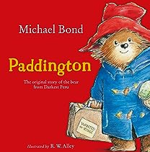 | 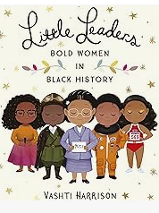  PS  HE | 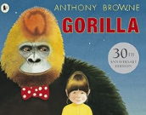 | 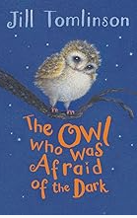 | 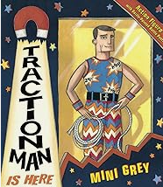 | 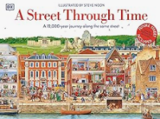 | 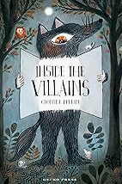 | 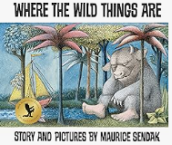 | 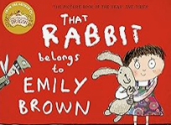 | 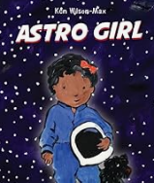 | 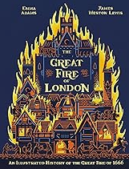 | 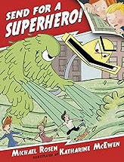
Paddington  by Michael Bond | Little Leaders  by Vashti Harrison | Gorilla  by Anthony Browne | The Owl Who Was Afraid Of The Dark  by Jill Tomlinson | Traction Man Is Here  by Mini Grey | A Street Through Time  by Steve Noon | Inside The Villain  by Clotilde Perrin | Where The Wild Things Are  by Maurice Sendak | That Rabbit Belongs To Emily Brown  by Cressida Cowell | Astro Girl  by Ken Wilson-Max | The Great Fire of London  by Emma Adams | Send for a Superhero  by Michael Rosen
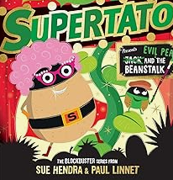 | 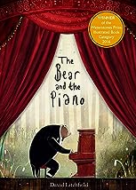 | 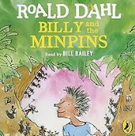 | 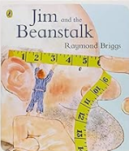 | 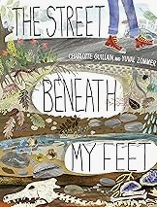 | 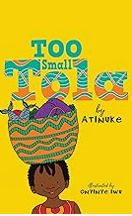 | 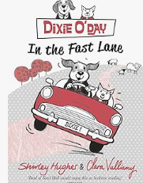 | 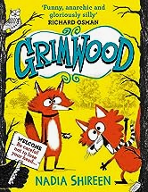 | 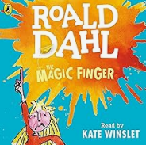 | 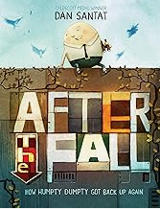 | 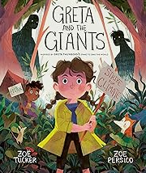 | 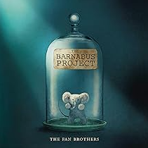
Supertato  by Sue Hendra | The Bear and The Piano  by David LIchfield | The Minpins  by Roald Dahl | Jim and the Beanstak  by Raymond Briggs | The Street beneath my Feet  by Charlotte Guillian | Too Small Tola  by Atinuke | Dixie O’Dayin the fast Lane  by Shirley Hughes | Grimwood  by Nadia Shireen | The Magic Finger  by Roald Dahl | After The Fall  by Dan Santat | Greta and the Giant  by Zoe Tucker | The Barnabus Project  by Eric Fan
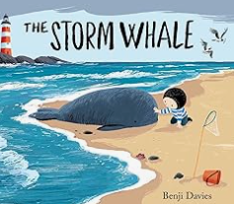 | 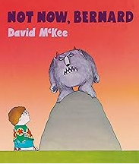 | 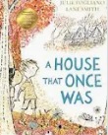 | 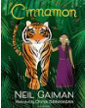 | 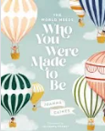  PS  HE | 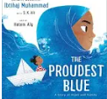 | 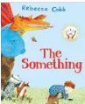 | 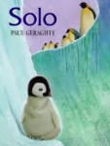 | 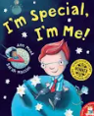 | 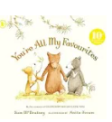 | 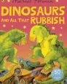 | 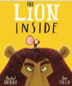
The Stormwhale  PS  HE  by Benji Davis | Not now, Bernard  by David McKee | The House that once was  by Julie Fogliano | Cinnamon  by Neil Gaiman | Who you were made to be  by Joanna Gaines | The proudest Blue  by Ibtihaj Muhammad | The Something  by Rebecca Cobb | Solo  by Paul Geraghty | I am Special, I am Me  PS  HE  by Ann Meek | You are All my Favourites  by Sam MacBratney | Dinosaurs and all that rubbish  by Michael Forerman | The Lion inside  by Rachel Bright
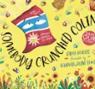 | 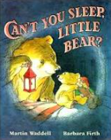 | 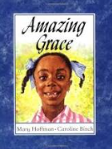 | 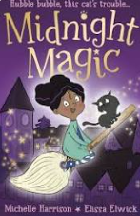 | 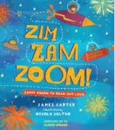 | 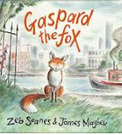 | 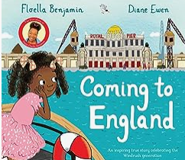 | 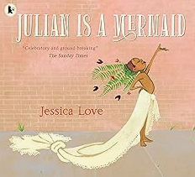  PC | 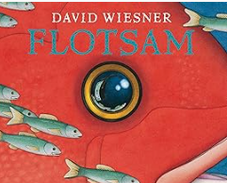  PC
Somebody crunched Colin  PS  HE  by Sarah Roberts | Can’t you sleep little Bear  by Martin Waddell | Amazing Grace  PS  HE  PS  HE  by Mary Hoffman | Midnight Magic  by Michelle Harrison | Zim Zam Zoom  by Jamers Carter | Garpard the Fox  by Zeb Soanes | Coming to England  by Floelle Benjamin | Julian is a mermaid  by Jessica Love | Flotsam  by David Wiesner
PS
HE

LKS2
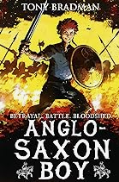 | 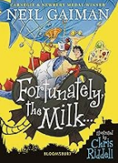 | 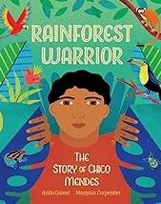  PS  HE  PS  HE | 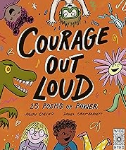 | 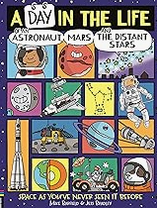 | 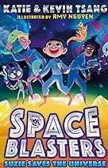 | 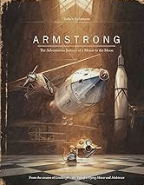 | 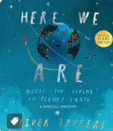 | 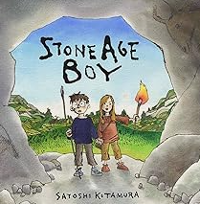 | 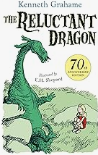 | 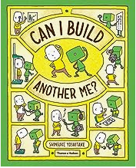 | 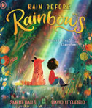
Anglo Saxon Boy  by Tony Bradman | Fortunately the Milk  by Neil Gaiman | Rainforest Warrior  by Anita Ganeri | Courage out Loud  PS  HE  by Joseph Coelho | A Day in the Life of an Astronaut  by Mike Barfield | Space Blasters  by Katie and Kevin Tsang | Armstrong – the adventurous journey ….  by Torben Kuhlman | Here we are  by Oliver Jeffers | Stone Age Boy  by Satoshi Kitamura | The Reluctant Dragon  by Kenneth Grahame | Can I build another me?  by Shinsuke Yoshitake | Rain before Raindrops  by Smiriti Halls
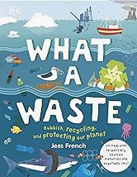  PS  HE | 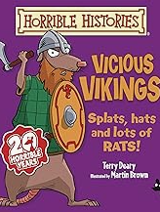 | 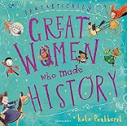  PS  HE | 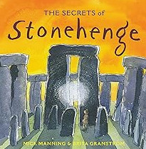 | 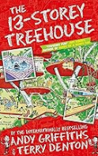 | 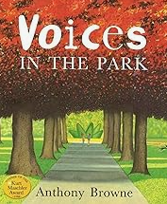 | 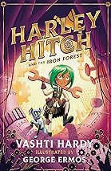 | 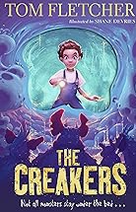 | 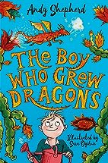 | 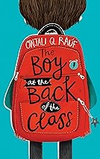 | 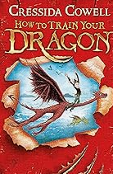 | 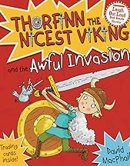
What a Waste  by Jess French | Vicious Vikings  by Terry Deary | Fantastically Great Women who made History  by Kate Pankhurst | The Secret of Stonehenge  by Mick Manning | The 13 Storey Treehouse  by Andy Griffith | Voices in the Park  by Anthony Browne | Harley Hitch and the Iron Forest  by Vashti Hardy | The Creakers by Tom Fletcher | The boy who grew dragons by Andy Shepherd | The boy at the back of the Class  by Onjali Rauf | How to train your Dragon  by Cressida Cowell | Thorfinn the nicest Viking by David MacPhail
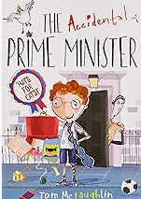 | 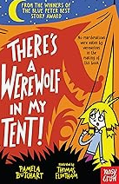 | 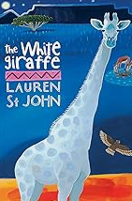 | 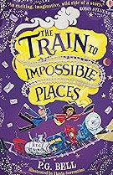 | 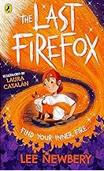 | 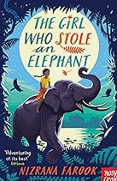 | 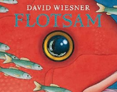  PS  HE | 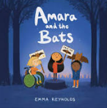  PS  HE | 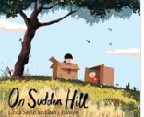 | 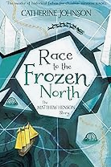  PS  HE | 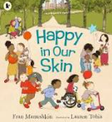 | 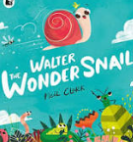  PS  HE  PS  HE
The Accidental Prime Minister by Tom McLaughlin | There is a Werewolf in my Tent  by Pamela Butchart | The white Giraffe by Lauren St John | The Train to Impossible Places by P.G. Bell | The Last Firefox  by Lee Newbery | The girl who stole an elephant  by Nizrana Farook | Flotsam  by David Wiesner | Amara and the Bats  by Anna Reynolds | On sudden Hill  By Linda Sarah | Race to the Frozen Northbvy Catherine Johnson | Happyinj our skin  by Fran Manushkin | Walter the wonder Snail  by Neil Clark
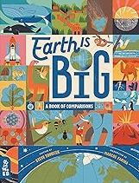 | 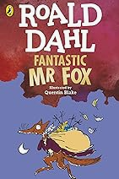
Earth is big  by | Fantastic Mr Fox  By Roald Dahl
PS
HE
UKS2
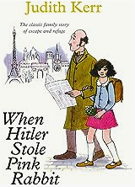 | 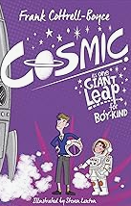 | 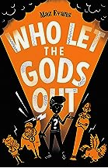 | 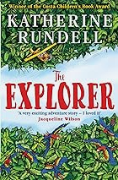 | 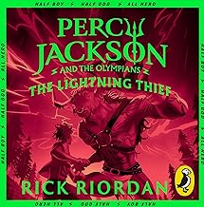 | 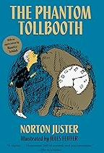 | 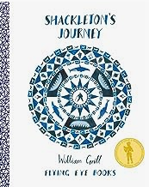 | 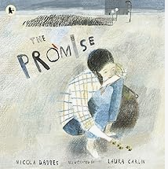 | 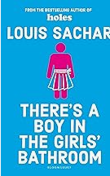 | 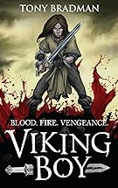 | 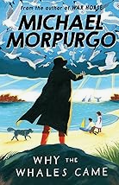 | 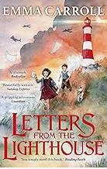
When Hitler stole Pink Rabbit  by Judith Kerr | Cosmic  by Frank Cottrell Boyce | Who let the Gods out?  by Maz Evans | The Explorer  by Katherine Rundell | Percy Jackson and the Lightning Thief  by Rick Riordan | The Phantom Tollbooth  by Norton Juster | Shackleton’s Journey  by William Grill | The Promise  PS  HE  by Nicola Davies | There is a boy in the girls’ bathroom  by Louis Sachar | Viking Boy  by Tony Bradman | Why the Whales came  by Michael Murporgo | Letters from the Lighthouse  by Emma Carroll
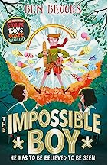 | 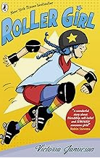 | 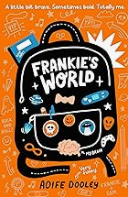 | 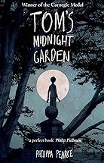 | 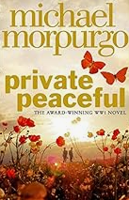 | 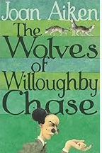 | 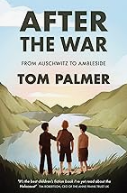 | 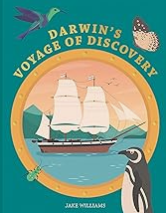 | 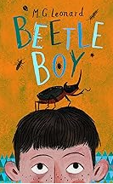 | 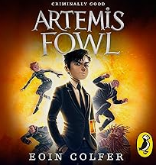 | 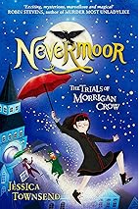 | 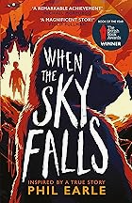
The Impossible Boy  by Ben Brooks | Roller Girl  by Victoria Jamieson | Frankie’s World  by Aoife Dooley | Tom’s Midnight Garden  by Philippa Pearce | Private Peaceful  by Michael Murporgo | The Wolves of Willoughby Chase  by Joan Aiken | After the War  by Tom Palmer | Darwin’s voyage of Discovery  by Jake Williams | Beetle Boy  by M.G. Leonard | Artemis Fowl  by Eoin Colfer | Nevermore  by Jessica Townsend | When the sky falls  by Phil Earle
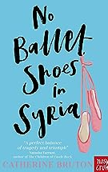 | 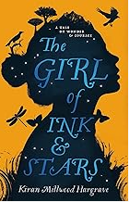 | 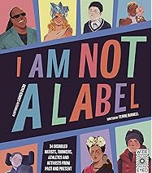 | 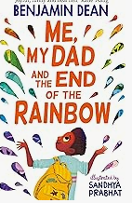 | 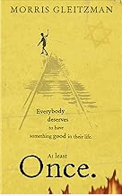 | 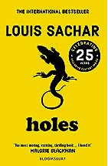 | 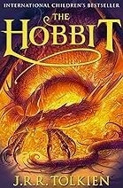 | 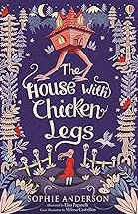 | 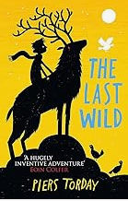 | 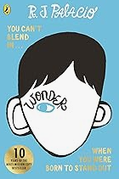  PS  HE | 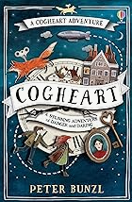 | 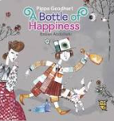  PS  HE
No Ballet shoes in Syria  by Catherine Bruton | The Girl of Ink and Star  by Kiran Millwood Hargrave | I am not a Label  PS  HE  by Cerrie Burnell | Me, my Dad and the End of the Rainbow  by Benjamin Dean | Once  by Morris Gleitzman | Holes  by Louis Sachar | The Hobbit  by J.R.R Tolkien | The House with Chicken Legs  by Sophie Anderson | The Last Wild  by Piers Torday | Wonder  by R. J. Palacio | Cogheart  by Peter Bunzl | A Bottle of Happiness  by Pippa Goodhart
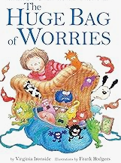  PS  HE | 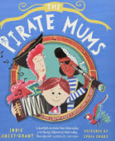 | PC
The Huge Bag of Worries  by Virginia Ironside | The Pirate Mums  by Jodie Lancet-Grant

