EYFS English Curriculum Long Term Plan
2023-24 Cycle B | Term 1 – Under the Night sky | Term 2 – Into the past | Term 3 – All at sea | Term 4 – Walking in different lands | Term 5 – Do-you-think-he-saurus | Term 6- From tiny seeds
Focus Text | 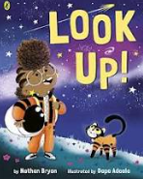  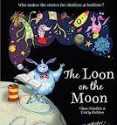  The Loon and the Moon  RS  Look up | 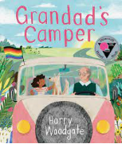  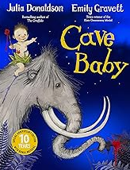  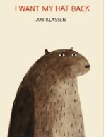  I want my hat back  RS  RS  Grandpa’s Camper van  Cave Baby | 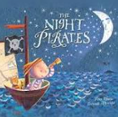  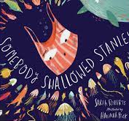  Night Pirates  RS  RS  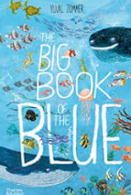  Someone Swallowed Stanley  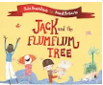  Jack and thr Flum Flum Tree | 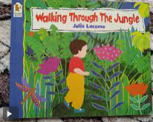  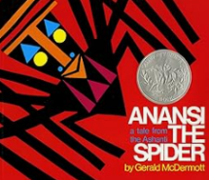  Anansi the spider  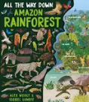  Walking through the jungle | 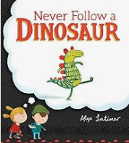  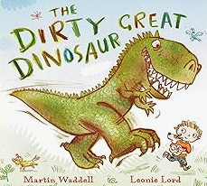  Never Follow a Dinosaur  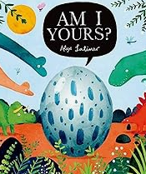  The Dirty Great Dinosaur  Am I yours? | 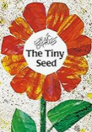  RS  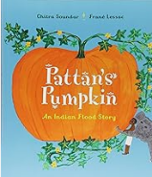  The Tiny Seed  RS  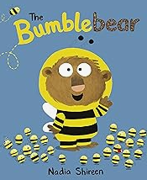  Pattan’s Pumpkin  Bumble Bear
Writing | Narrative - Verbal and pictorial storytelling  Mark making  Name writing  Writing of initial sounds | Narrative – Name writing with correct letter formation, write CVC words  Postcards, speech bubbles, Wanted poster  Non-fiction – verbal recounts | Narrative – Use correct letter formation  Use letter sound knowledge to write short sentences, beginning to use Capital letters and full stops  Re-read sentences to check for sense  Write HF words from SW programme | Recount- visit to Living Rainforest, use letter-sound knowledge to write, apply Capital letters and full stops, re-read sentences to check for sense, write HF words from SW programme | Form most letters correctly  Write known HF words  Apply letter sound knowledge, Capital letters and full stops  Write simple phrases that can be read by others  Start to include adjectives | Write a series of short sentences  Re-read their work to check for sense
Poetry | 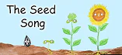 Harvest song-The farmer plants a seed  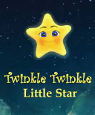  Call and response |  |  | Song lyrics re-invented | Rhyme narrative flip book | Tree Whisper Poem
Word Reading, using Sounds Write Phonics Programme | Sounds Write – Initial code Unit1-4  (a, i, m, s, t, n, o, p, b, c, g, h, d, e, f, v), VC and CVC words |  | Sounds Write – Initial code Unit 5-7 (k, l, r, u, j, w, z, x, y, ff, ll, ss, zz) VC and CVC words |  | Sounds Write – Initial Code Unit 8-11 vcc, cvcc, ccvc, ccvcc, cvccc, cccvc words. sh, ch, th, ck, wh, ng, qu
Reading Comprehension | Word Reading:  - Read words consistent with their phonic knowledge by sound-blending.  - Read aloud simple sentences and books that are consistent with their phonic knowledge, including some common exception words.  Comparing, Contrasting and commenting:  - Listen attentively and respond to what they hear with relevant questions, comments and actions when being read to and during whole class discussions and small group interactions.  - Make comments about what they have heard and ask questions to clarify their understanding. Hold conversation when engaged in back-and forth exchanges with their teacher and peers  - Demonstrate understanding of what has been read to them by retelling stories and narratives using their own words and recently introduced vocabulary.  - Offer explanations for why things might happen, making use of recently introduced vocabulary from stories, non-fiction, rhymes and poems when appropriate  - Explain some similarities and differences in different contexts by drawing on their experiences and what has been read in class, drawing on knowledge from stories and non-fiction texts.  - Understand the past through settings, characters and events encountered in books read in class and storytelling.  Words in context and authorial choice:  - Participate in small group, class and one-to-one discussions, offering their own ideas, using recently introduced vocabulary.  - Use and understand recently introduced vocabulary during discussions about stories, non-fiction, rhymes and poems and during role-play  - Offer explanations for why things might happen, making use of recently introduced vocabulary from stories, non-fiction, rhymes and poems when appropriate.  Inference and Prediction:  Anticipate – where appropriate – key events in stories.  Performance:  - Invent, adapt and recount narratives and stories with peers and their teacher.  - Sing a range of well-known nursery rhymes and songs.  - Make use of props and materials when role playing characters in narratives and stories.  - Perform songs, rhymes, poems and stories with others.
Additional Texts | Whatever Next?  RS  Man on the Moon |  | The Crocodile who didn’t like water  RS  Oi Frog | Rosie’s Walk  RS  Little Red  We are going on a Bear Hunt | Harry and the  Dinosaurs  Tyrannosaurus Drip  Ravi’s Roar

KS1 English Curriculum Long Term Plan
2023-24 | Term 1  Up, up and away | Term 2  Long, long ago | Term 3  In the wild | Term 4  Lights in the sea | Term 5  Roaring dinosaurs | Term 6  Grow mw a story
Focus Text | 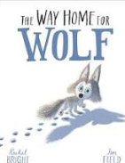  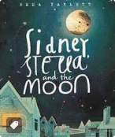  The way home for wolf  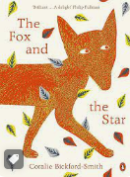  Sidney, Stella and the moon  The Fox and the Star | 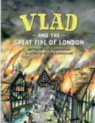  Vlad and the Great Fire of London  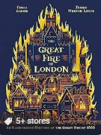  RS  The Great Fire of London | 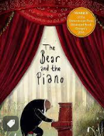  The Bear and the Piano  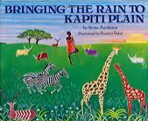  Bringing the rain to Kapiti Plain | 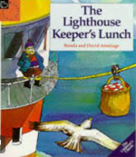  The Lighthouse Keeper’s Lunch  The story of Grace Darling | 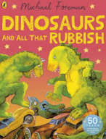  Dinosaurs and all that Rubbish  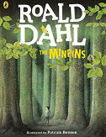  RS  The Minpins | 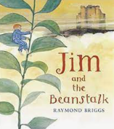  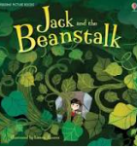  Jack and the beanstalk  RS  Jim and the beanstalk
Writing Genre | Narrative – Retelling of a story  Non-narrative – Information booklet about the moon | Narrative – Retelling, Writing a series of diary entries, The Great Fire of London from an animals point of view  Non-fiction – Report about The Great Fire of London, Bread making Instruction text | Narrative – Own version narrative about bravery  Non-fiction- Information leaflet about the rainforest | Narrative –Adventure in a different kind of home, Letter writing  Non-fiction – Report about the life of Grace Darling | Narrative – Adventure story about overcoming fear  Non-fiction- Pamphlet about looking after the environment | Narrative- Fairy Tales, own version of a fairy tale
Poetry | Blast off – Performance Poetry |  | Rainforest Senses Poem |  | Simile Poem about the world
Additional Texts | Astro girl  RS  The owl who was  afraid of the dark | Cakes in space  Christmas Stories | Harry the poisonous centipede  RS  The Hodgeheg  Fantastic Mr Fox | The secret of Black  RS  rock  Sulwe  The Storm whale | The diary of a Killer  RS  Cat  The 100 mile an hour dog  Where the wild things are | After the Fall  RS  Mr Majika
Word Reading, using Sounds Write Phonics Programme | Year 1:  SW Unit EC 1-3  Year 2:  Revise SW Unit 1-20, EC Unit 21-26 | Year 1: SW Unit EC 4-6  Year 2: SW Unit EC 27-29 | Year 1: SW Unit EC 7-9 Year 2: SW Unit EC 30-33 | Year 1: SW Unit EC 10-11  Year 2: SW Unit EC 34-36 | Year 1: SW Unit EC 12, 13, 19, 23, 24  Year 2: SW Unit EC 37-42 | Year 1: SW Unit EC 14-18, 20-22  Year 2: Sounds Write Unit EC 43-49
Reading Comprehension | Understanding and correcting inaccuracies:  Year 1:  - To check that a text makes sense to them as they read and to self- correct.  Year 2:  - To show understanding by drawing on what they already know or on background information and vocabulary provided by the teacher. To check that the text makes sense to them as they read and to correct inaccurate reading  Comparing, contrasting and commenting:  Year 1:  - To listen to and discuss a wide range of fiction, non-fiction and poetry at a level beyond that at which they can read independently.  - To join in with discussions about a text, taking turns and listening to what others say.  - To link what they have read or have read to them to their own experiences.  - To retell familiar stories in increasing detail. To discuss the significance of titles and events  Year 2:  - To ask and answer questions about a text. To become increasingly familiar with and to retell a wide range of stories, fairy stories and traditional tales.  - To participate in discussion about books, poems and other works that are read to them (at a level beyond at which they can read independently) and those that they can read for themselves, explaining their understanding and expressing their views.  - To discuss the sequence of events in books and how items of information are identifiable  Words in context and authorial choice:  Year 1:  - To discuss word meaning and link new meanings to those already known.  Year 2:  - To discuss and clarify the meanings of words, linking new meanings to known vocabulary.  - To discuss their favourite words and phrases.  Inference and Prediction:  Year 1:  - To begin to make simple inferences.  - To predict what might happen on the basis of what has been read so far.  Year 2:  - To make inferences on the basis of what is being said and done.  - To predict what might happen on the basis of what has been read so far in a text

LKS 2 English Curriculum Long Term Planning
2023-24 | Term 1  Going Places | Term 2  Anglo Saxons | Term 3  Vikings | Term 4  Extreme Survivors | Term 5  The land of roar | Term 6  Iron Age
Focus Text | 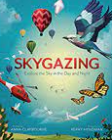  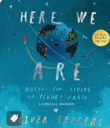  RS | 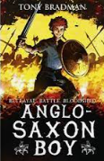  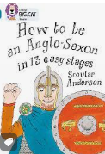  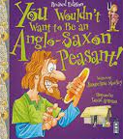  RS | 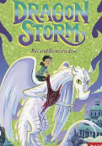  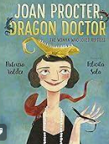  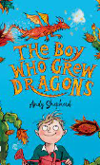  RS | 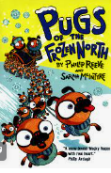  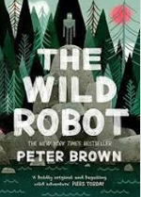 | 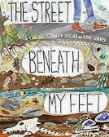  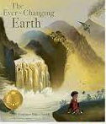 | 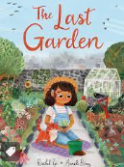  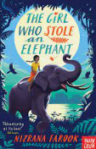  RS
Writing Genre | Narrative – Retelling of story, changing of character  Non-fiction – Information text  Biography Yuri Gagarin | Narrative – Setting and character description  Non-fiction – Information booklet | Narrative – Exploring a chapter  Letters  Non-fiction- | Narrative –  Non-fiction – Instructions, Biography, Diary | Non-fiction- Formal and informal letter, persuasive writing Explanation, Leaflet | Narrative – extended writing  Non-fiction – Recount (trip?)
Themes | Magic and Wonder | Exploration and discovery | Nature vs technology | Mystery and Truth | Evolution and Inheritance  Urban mystery | Ambition and Desire
Poetry | Harvest Poem – Acrostic  This is me - Competition |  |  | Kenning
Additional Texts | 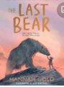 | Excitable Edgar - Advert | 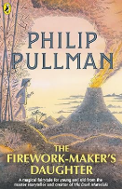 | 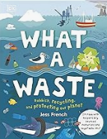  My Strong Mind | 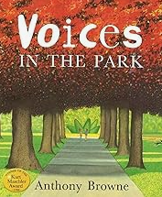  Biography David Attenborough | 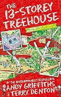  13 Storey Treehouse
Reading Comprehension | Comparing, Contrasting and commenting:  Year 3:  - To recognise, listen to and discuss a wide range of fiction, poetry, plays, non-fiction and reference books or textbooks.  - To make links between the text they are reading and other texts they have read (in texts that they can read independently).  - To use appropriate terminology when discussing texts (plot, character, setting). To recognise simple recurring literary language in stories and poetry.  Year 4:  - To read for a range of purposes.  - To discuss and compare texts from a wide variety of genres and writers. To identify themes and conventions in a wide range of books.  - To refer to authorial style, overall themes (e. g. triumph of good over evil) and features (e.g. greeting in letters, a diary written in the first person or the use of presentational devices such as numbering and bullet points  - To identify how language, structure and presentation contribute to meaning.  - To identify main ideas drawn from more than one paragraph and summarise these headings)  Words in context and authorial choice:  Year 3:  - To check that the text makes sense to them, discussing their understanding and explaining the meaning of words in context.  - To discuss authors’ choice of words and phrases for effect.  Year 4:  To discuss vocabulary used to capture readers’ interest and imagination.  Inference and Prediction:  Year 3:  - To ask and answer questions appropriately, including some simple inference questions based on characters’ feelings, thoughts and motives.  - To justify predictions using evidence from the text.  Year 4:  - To draw inferences from characters’ feelings, thoughts and motives that justifies their actions, supporting their views with evidence from the text.  - To justify predictions from details stated and implied.  Performance:  Year 3:  - To prepare and perform poems and play scripts that show some awareness of the audience when reading aloud.  - To begin to use appropriate intonation and volume when reading aloud  Year 4:  - To recognise and discuss some different forms of poetry (e.g. free verse or narrative poetry).  - To prepare and perform poems and play scripts with appropriate techniques (intonation, tone, volume and action) to show awareness of the audience when reading aloud

UKS2 English Curriculum Long Term Planning
2023-24 | Term 1 – One small step | Term 2- Don’t burn the cakes | Term 3- The last Kingdom | Term 4-Walking through the jungle | Term 5- Stone Age | Term 6 - Evolution
Focus Text | 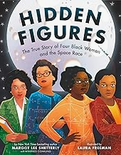  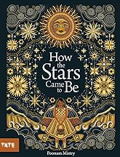 | 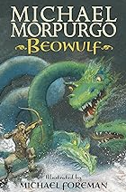  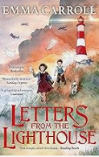  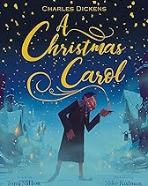 | 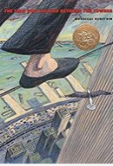  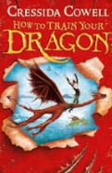  RS | 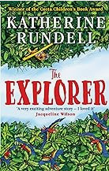  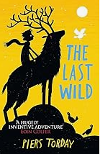  RS  RS | 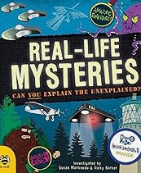  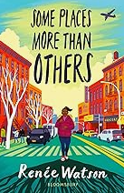 | 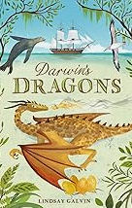  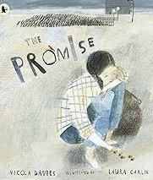
Writing Genre | Narrative – Retelling of story with changed characters  Non-fiction –  Biography | Narrative – Setting and character description, letters, dialogue,  Non-fiction – Newspaper report | Narrative – Settings, characters, emotions  Non-fiction- Formal and informal letters, persuasive writing | Narrative – Dialogue, openers, descriptive language  Non-fiction – Reports, diary, posters, letters | Non-fiction- Information leaflet, Instructions  Narrative | Narrative – figurative language  Non-fiction – Recount (trip?)
Themes | Exploration and discovery | Magic and Wonder | Nature vs technology | Mystery and Truth | Evolution and Inheritance  Urban mystery | Ambition and Desire
Poetry | Free form poetry | The Night before Christmas |  |  | Sense Poem
Additional Texts | Cosmic |  |  |  | 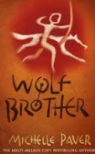 Wolf Brother | Darwin’s voyage of Discovery
Reading Comprehension | Comparing, contrasting and commenting:  Year 5:  - To read a wide range of genres, identifying the characteristics of text types (such as the use of the first person in writing diaries and autobiographies) and differences between text types.  - To participate in discussions about books that are read to them and those they can read for themselves, building on their own and others’ ideas and challenging views courteously.  - To recommend texts to peers based on personal choices.  - To identify main ideas drawn from more than one paragraph and to summarise these.  Year 6:  - To read for pleasure, discussing, comparing and evaluating in depth across a wide range of genres, including myths, legends, traditional stories, modern fiction, fiction from our literary heritage and books from other cultures and traditions.  - To listen to guidance and feedback on the quality of their explanations and contributions to discussions and to make improvements when participating in discussions.  - To explain and discuss their understanding of what they have read, including through formal presentations and debates, maintaining a focus on the topic and using notes where necessary.  - To recognise more complex themes in what they read (such as loss or heroism).  - To draw out key information and to summarise the main ideas in a text.  - To compare characters, settings and themes within a text and across more than one text  - To distinguish independently between statements of fact and opinion, providing reasoned justifications for their views.  Words in context and authorial choicer:  Year 5:  - To discuss vocabulary used by the author to create effect including figurative language.  - To evaluate the use of authors’ language and explain how it has created an impact on  Year 6:  - To analyse and evaluate the use of language, including figurative language and how it is used for effect, using technical terminology such as metaphor, simile, analogy, imagery, style and effect  Inference and prediction:  Year 5:  - To draw inferences from characters’ feelings, thoughts and motives.  - To make predictions based on details stated and implied, justifying them in detail with evidence from the text  Year 6:  - To consider different accounts of the same event and to discuss viewpoints (both of authors and of fictional characters).  - To discuss how characters change and develop through texts by drawing inferences based on indirect clues  Performance:  Year 5:  To continually show an awareness of audience when reading out loud using intonation, tone, volume and action  Year 6:  To confidently perform texts (including poems learnt by heart) using a wide range of devices to engage the audience and for effect.

